Press Release

Date 18.08.2020
No. PI 2259
Number of characters 2592
Contact Muller Martini AG
Untere Brühlstrasse 17, 4800 Zofingen, Switzerland
Phone +41(0)62 745 45 45
info@mullermartini.com, www.mullermartini.com

New Alegro for Even More Efficient Production of Perfect-bound Products

This November, Eberl & Kœsel will put a new Alegro perfect binding line from Muller Martini into operation – sending a clear signal of the company’s efforts to actively shape its economic future at its location in the German city of Altusried-Krugzell.

The new Alegro with a 24-station gathering machine, Universo stack delivery, endsheet feeder, crash station, Solit three-knife trimmer, CB18 book stacker and Pluton palletizer is a true all-rounder. It replaces an older Kolbus Ratio perfect binder at Eberl & Kœsel. “This investment represents another step toward the fully digital production of the highest-quality small print runs, and will also allow us to offer our customers bind on-demand in addition to print on-demand,” says Managing Director Joachim Kühn.

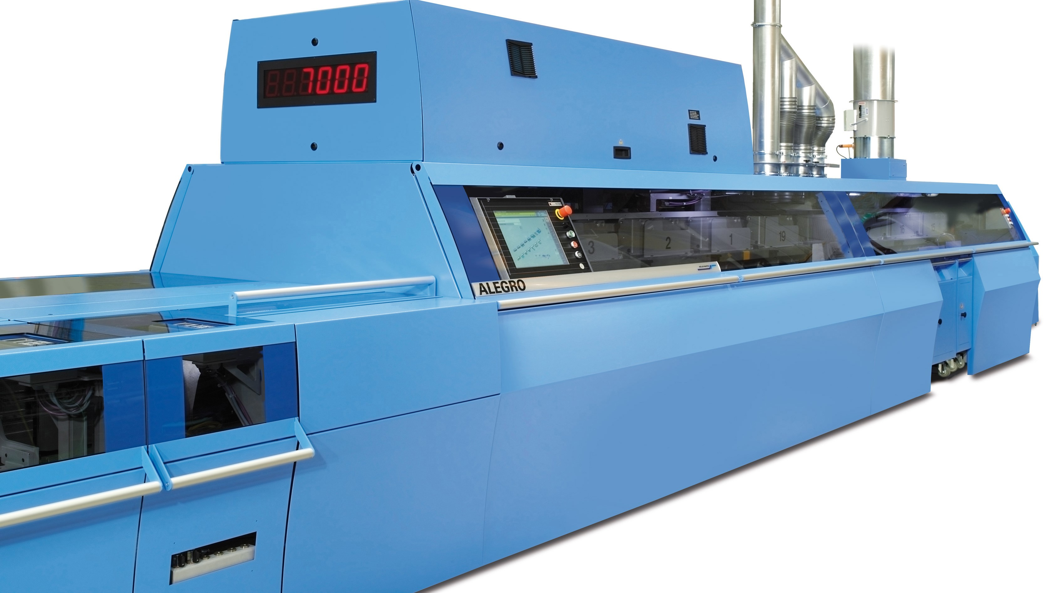
Thanks to the new Alegro perfect binding line, Eberl and Kœsel will be able to offer its customer bind on-demand in the future as well.

Joachim Kühn anticipates a clear improvement in quality, especially as a result of the Asir 3 barcode and image recognition at all 24 gathering machine stations and at the cover feeder. “This will prevent an incorrect signature sequence and guarantee that the content and covers match.”

Emulsion gluing ensures optimal layflat behavior, while PUR nozzle gluing provides precise glue application and the best durability, even with heavy paper. And modern IR and HF drying increases the energy efficiency of the new perfect binding line, which is capable of being modified to include automated digital book block feeding.

Eberl & Kœsel was created as a result of the merger of Eberl print GmbH, part of the Eberl Medien group of companies, and Kösel GmbH & Co. KG at the beginning of 2020. With around 280 employees, Eberl & Kœsel is already one of the leading printing plants in German-speaking countries. The company provides its customers – including industrial companies, publishing houses and agencies, mainly in Germany, Austria and Switzerland – with service from its location in Altusried-Krugzell. The company is known for high-quality and highly innovative printed matter, from challenging single items to high-volume runs. As part of the merger, Eberl & Kœsel Factory was created as a separate main brand, focusing on providing efficiency and cost-optimized processes to the benefit of its customers.

