

Press Release

Date: 21.12.2017
No. PI 2122
Number of characters 2496
Contact Muller Martini AG
Untere Brühlstrasse 13, 4800 Zofingen, Switzerland
Tel. +41 (0)62 745 45 75, Fax +41 (0)62 751 55 50
info@mullermartini.com, www.mullermartini.com

Dar Al-Nahrain (Baghdad) – Higher Efficiency Thanks to Muller Martini Solutions

For a year now, the Dar Al-Nahrain for Printing graphic arts company in the Iraqi capital of Baghdad has been using five Muller Martini systems, enabling it to significantly increase its print finishing efficiency.

After drupa 2016, Dar Al-Nahrain for Printing made major investments in print finishing, acquiring two Alegro perfect binders, two Ventura MC thread sewing machines and a Presto II saddle stitcher. “We decided on Muller solutions for three main reasons,” says Managing Director Duraid Dh. Da’as. “First, they are ideal for our job structure. Second, they ensure high productivity thanks to their speed and reliability. Third, we have an excellent partnership with Imad Chebaro and Elie Hamaty from Muller Martini’s regional agency, Middle East Graphics. And fourth, ^{MM}Remote is extremely important for us, as accessing the remote maintenance from the Müller Martini factory in the event of any machine problems is easier than having service technicians flown in from several thousand kilometers away.”

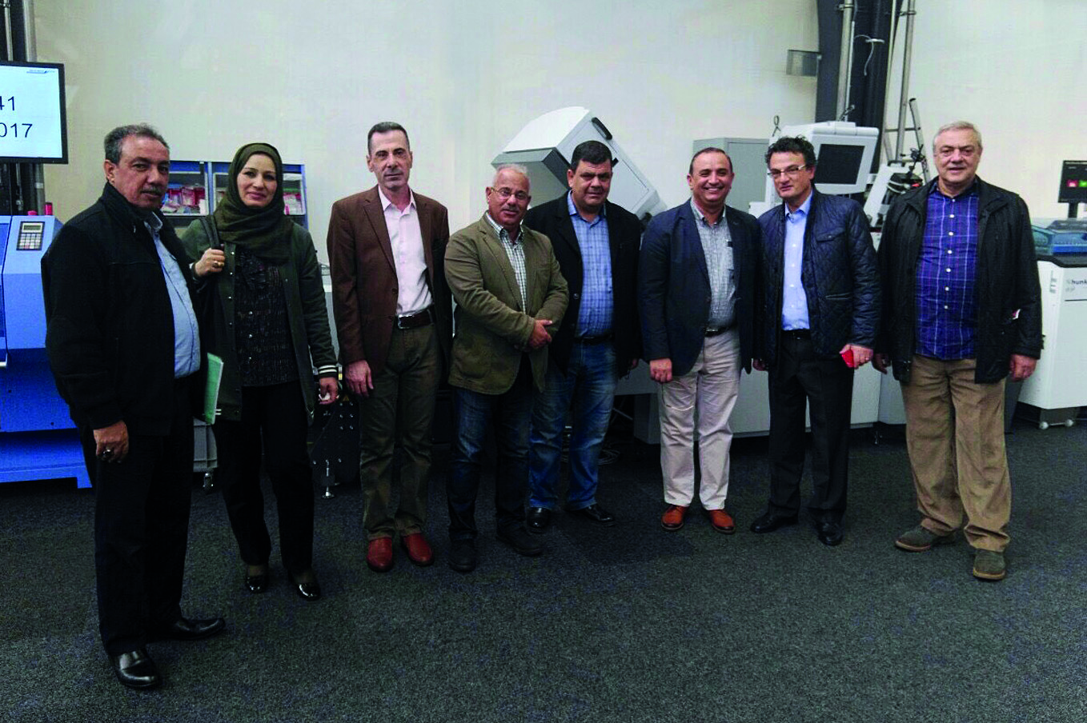
The delegation from Dar Al-Nahrain for Printing together with Enrico Farinacci, Sales Manager at Muller Martini (second from the right) and Elie Hamaty, Sales and Support at Middle East Graphics (right), at the Muller Martini Print Finishing Center in Zofingen.

Dar Al-Nahrain for Printing, which was established in 1979 by the Iraqi government and employs 400 people, produces for customers throughout Iraq, but predominantly for government institutions, especially the Ministry of Education. Such institutions turn to the graphic arts company in Baghdad not least because under Iraqi law all print products commissioned by government bodies must be printed in Iraq.

In addition to school textbooks and examination papers, from elementary school through to university level, Dar Al-Nahrain for Printing produces various magazines. The Baghdad-based company uses both offset and digital printing. During a live demo at the Muller Martini Print Finishing Center in Zofingen in Switzerland, a delegation from Dar Al-Nahrain recently saw what possibilities Muller Martini’s Finishing 4.0 solutions offer for digital printing. “Digital printing is getting popular in our country,” says Duraid Dh. Da’as. “I expect it to continue to gain in importance. In any case, we’re extremely well prepared, we have set up a designated digital department at our company and we are planning to invest more in this field.”

