Press Release

Date 02.27.2020
No. PI 2243
Number of characters 1697
Contact Müller Martini AG
Untere Brühlstrasse 17, 4800 Zofingen, Switzerland
Tel. +41 (0)62 745 45 45
info@mullermartini.com, www.mullermartini.com

Exklusiv für MM-Homepage!

Doubling Hardcover Production with the New Diamant MC 60

As a replacement for its Kolbus BF 525, which dated back to 1996, SFA Print (P) Ltd., in the Indian printing industry stronghold of Sivakasi, commissioned a new Diamant MC bookline from Muller Martini.

With its investment in the latest book manufacturing technology the company, which was founded in Tamil Nadu state in 1964 and employs 210 people, has set itself an ambitious goal. “We want to double hardcover production,” say the company’s two directors, V. Ganesh Kumar and V. Srinivas.
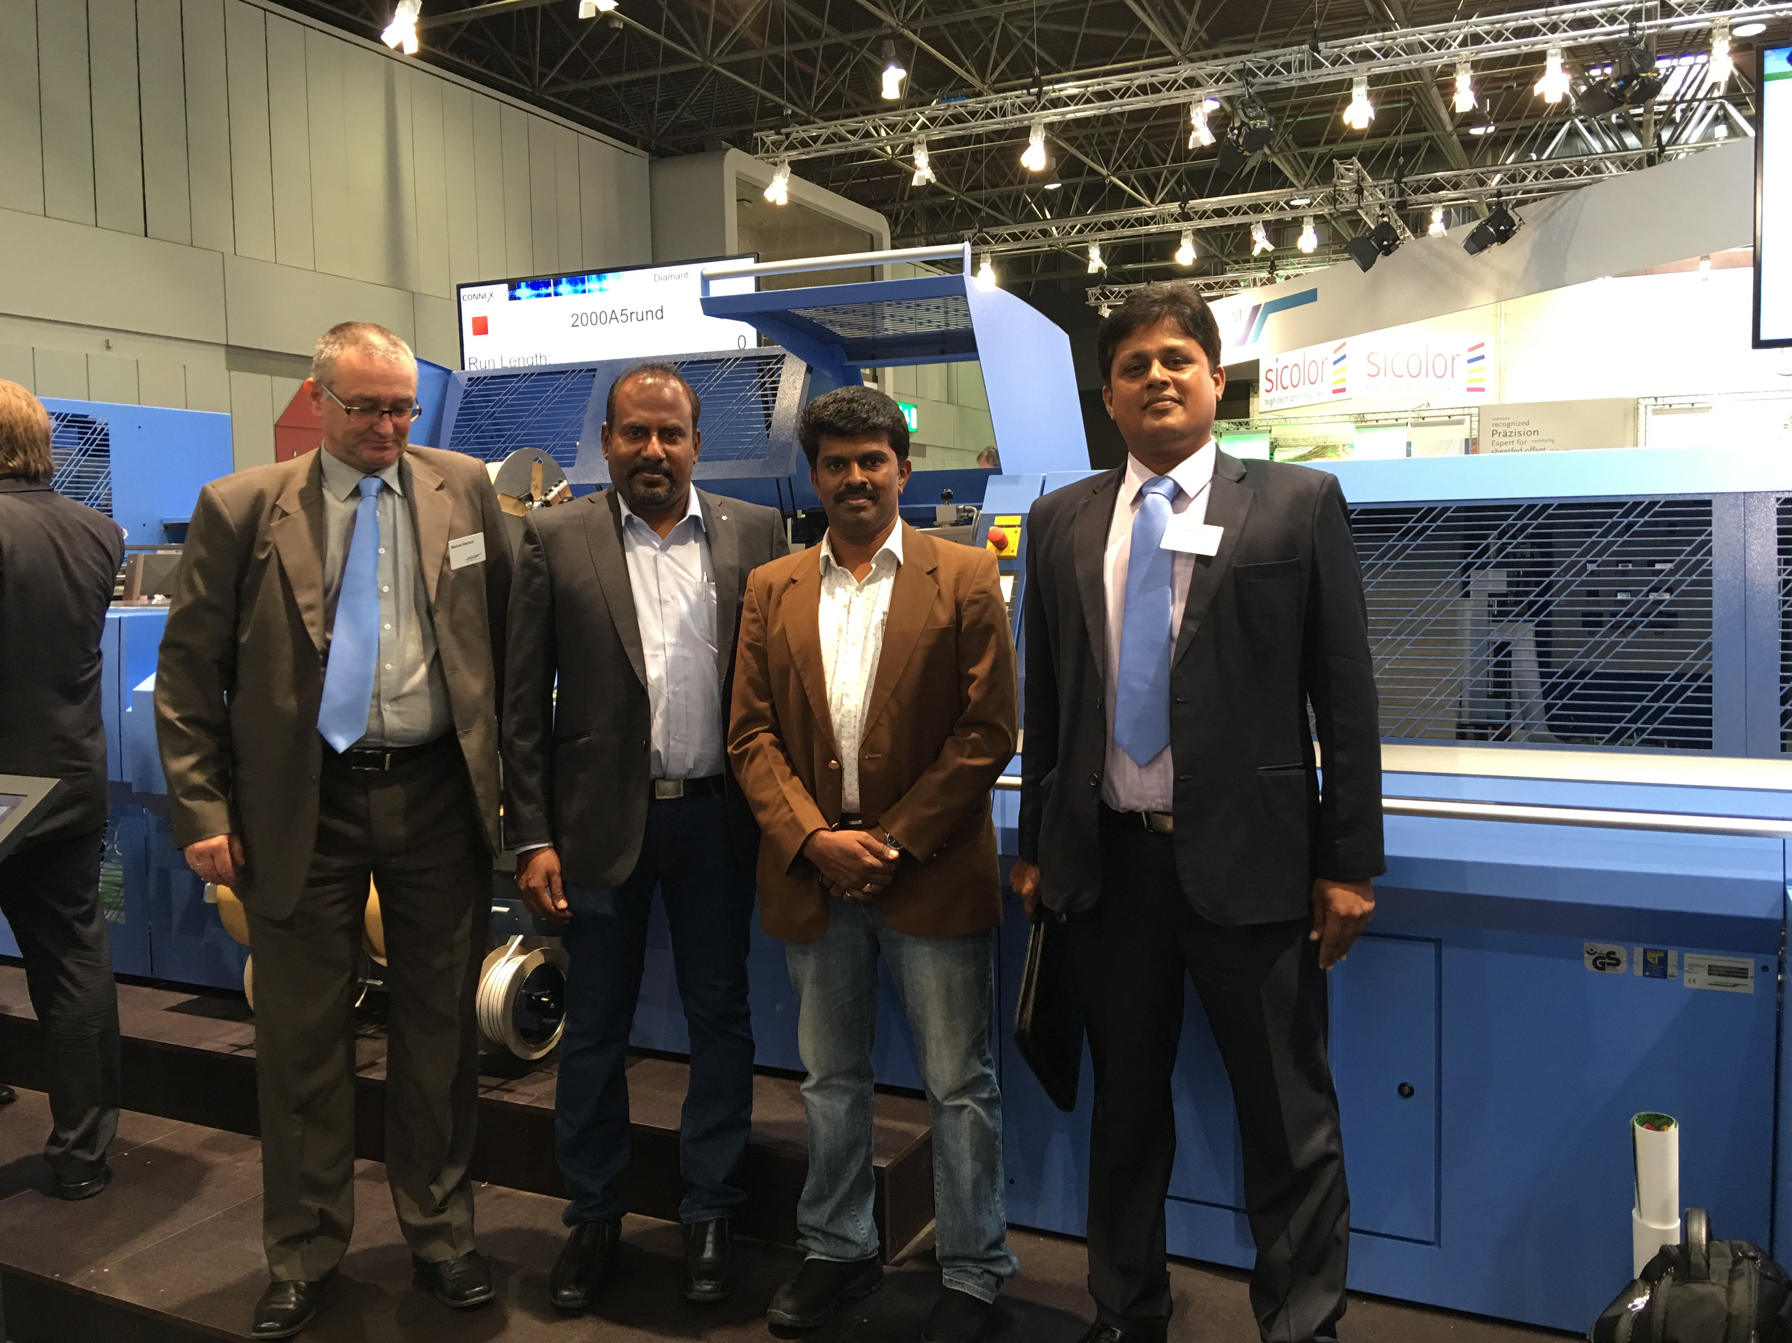

From right to left: S. Parthasarathy (Assistant Sales Manager Muller Martini India), V. Ganesh Kumar (Director SFA Print), V. Srinivas (Director SFA Print) and Michael Starford (Sales Manager Muller Martini Asia Pacific) standing in front of the new Diamant MC 60 at SFA Print in Sivakasi).

SFA Print (P) Ltd., a full-service company that offers pre-press, printing and print finishing services, provides its customers with a full range of graphic arts products – from notebooks to advertising materials to diaries and calendars. In addition to these stationary products, hardcover books are an important focus as well.

“Thanks to the Diamant MC 60 we can continue to offer our customers high quality,” say V. Ganesh Kumar and V. Srinivas. “And because the new bookline has a high cycle speed of 3,600 copies per hour, it has also boosted net output substantially and increased the range of book production options.” SFA Print chose Muller Martini in part because of the long-term successful partnership between the two companies. The Indian printer has relied on a Muller Martini Point perfect binder for softcover production for many years.

