Press Release

Date 02.20.2020
No. PI 2235
Number of characters 2140
Contact Muller Martini AG
Untere Brühlstrasse 13, 4800 Zofingen, Switzerland
Tel. +41 (0)62 745 45 75, Fax +41 (0)62 751 55 50
info@mullermartini.com, www.mullermartini.com

Jumping Across the Plata River

With the acquisition of an Alegro perfect binder from Muller Martini, Argentine full-service company Arcángel Maggio has created the basis for a successful branch in neighboring Uruguay.

A wide estuary formed by the confluence of two South American rivers divides Argentina and Uruguay. But the Plata River is no barrier to the company in Buenos Aires on its way to becoming the largest exporter of books in the region. It opened a production complex in Colonia del Sacramento that occupies 4,000 m², half the size of the company’s facility in Barracas, a neighborhood in the Argentine capital. An important part of the investment volume in Uruguay is a Muller Martini Alegro perfect binder with an 18-station 3694 gathering machine, a Book Data Center, a Frontero front trimmer, a Solit three-knife trimmer and a CB18 book stacker.
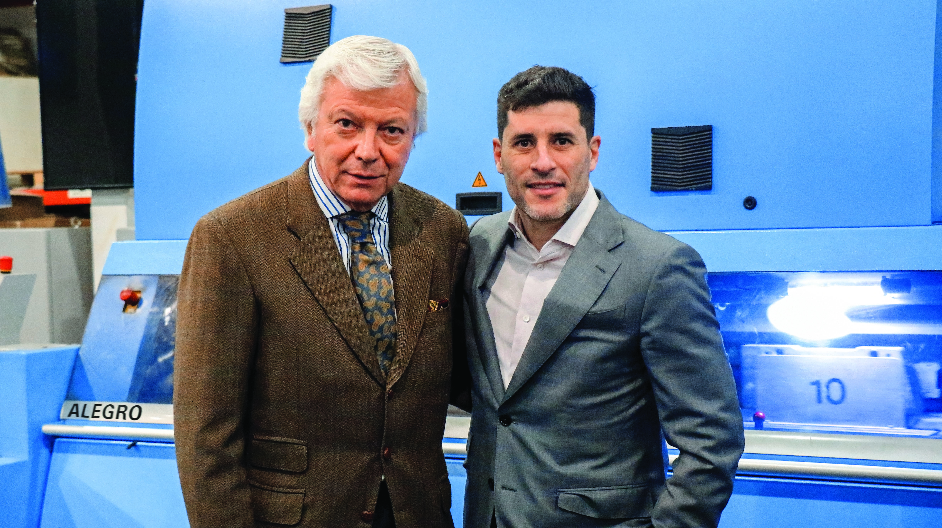

CEO Sebastián Maggio (right): “We chose an Alegro for our new plant in Uruguay based on our excellent experience with the Acoro in Barracas.” Left: Carlos Rojas, Managing Director of Muller Martini Argentina.

“We chose an Alegro for our new plant in Uruguay based on our excellent experience with the Acoro in Barracas,” says Sebastián Maggio, praising the proven partnership with Muller Martini. The CEO is confident that his company has one of the most modern perfect binding lines in Latin America. As is the case in Barracas, the company's new location also has a Frontero front trimmer that ensures the economical production of brochures with flaps. The Argentine family-run company hopes to serve customers throughout all of Latin America from its Uruguay location.

Sebastián Maggio appreciates the high net output and level of automation of the Muller Martini systems his company uses. But he is also impressed with the quality of the end products. This quality has won the company a number of major awards in recent years. The Alegro at the company’s facility in Uruguay serves as additional motivation because the 7,000-cycle perfect binder is very user friendly and can be changed over very quickly. The high expectations of Arcángel Maggio have also been met in terms of product quality.

