Press Release

Date 20.03.2018
No. PI 2136
Number of characters 1623
Contact Muller Martini AG
Untere Brühlstrasse 13, CH-4800 Zofingen/Switzerland
Tel. +41 (0)62 745 45 75, Fax +41 (0)62 751 55 50
info@mullermartini.com, www.mullermartini.com

Touchless Workflow from
Imposition to the Finished Book

By investing in a complete SigmaLine with SigmaControl, Connex Line Control Pro, a SigmaFolder II and a SigmaCollator, Log & Print Gráfica Dados Variáveis e Logística SA in the Brazilian municipality of Barueri will secure its position on the fiercely competitive (digital) book market.

Industrial Director Mauricio Ramon Bouzadas Lamas explains that the well-established company opted for the Muller Martini digital book production system chiefly because of the SigmaLine’s versatility. “Thanks to SigmaControl and Connex, it’s the most sophisticated solution on the market and is optimally designed for the print finishing of our digitally printed products.” The SigmaLine ensures a seamless production transition from the mill roll to the ready book blocks. “That gives us a touchless workflow from imposition and printing through to the finished book, including quality checks, and will enable us to retain our strong position on the fiercely competitive book market,” says Mauricio Roman Bouzadas Lamas.

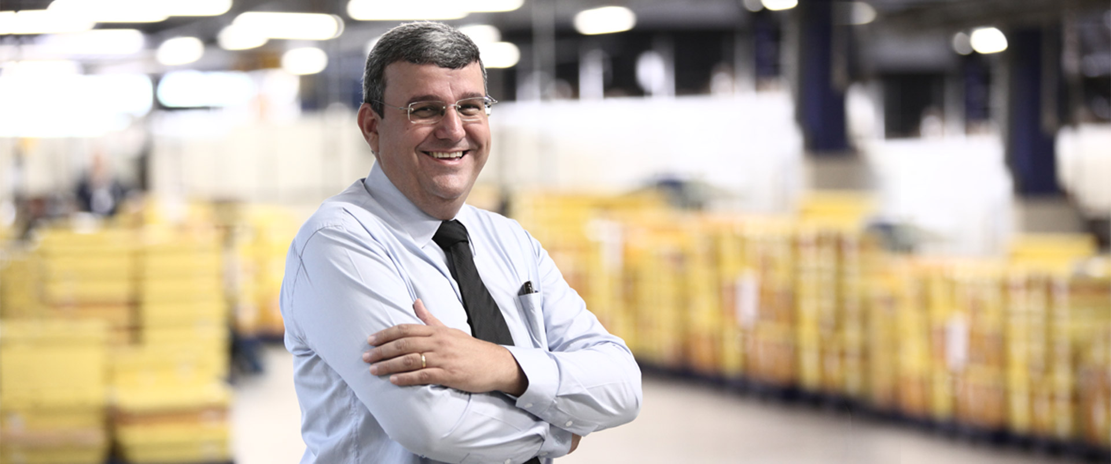Mauricio Ramon Bouzadas Lamas, Industrial Director of Log & Print: “The SigmaLine will enable us to retain our strong position on the fiercely competitive book market.”

The graphic arts company Log & Print Gráfica Dados Variáveis e Logística SA – which was founded in 1992, employs 1,400 people and has an impressive production area of 23,000 m² – will primarily use the SigmaLine to produce school textbooks, as well as other softcover books, in run sizes of between 500 and 5,000 copies. In tandem with its investment in the SigmaLine, the Brazilian company will also commission a state-of-the-art HP T470HD digital printing press, which will be connected inline with the Muller Martini book production system. It will join the company’s current digital printing press line-up of five Ricoh IP 5000 presses and two Oce/Canon Colorstream 3900 presses.

