Media information

Date 26.02.2025
No. PI 2483
Number of characters 2014
Contact Müller Martini AG
Untere Brühlstrasse 17, 4800 Zofingen/Switzerland
Phone +41 62 745 45 45
info@mullermartini.com, www.mullermartini.com

CPB Explores the Latest Trends at the Muller Martini Booth

Uilson Garcia, President of Casa Publicadora Brasileira (CPB), and his team visited the Hunkeler Innovationdays to find out about the future of digital printing. CPB, a Christian publishing house in Tatui, São Paulo, Brazil, produces a wide range of print products and has been an important partner of Muller Martini for many years. The full-service provider uses state-of-the-art printing and binding technologies to produce high-quality books and magazines for the Seventh-day Adventist Church.

“At CPB, we have traditionally worked in offset,” says Uilson Garcia. ”However, in the future, some areas of our production will likely rely more heavily on digital solutions. Today, we work with partners who print digitally for us, and it is important for us to get to know the new, innovative solutions that will likely also become part of our business.”

According to Uilson Garcia, Muller Martini is one of CPB's most important production partners: “Muller Martini offers the highest quality service and products that support us with cutting-edge technology, innovation and production quality.”

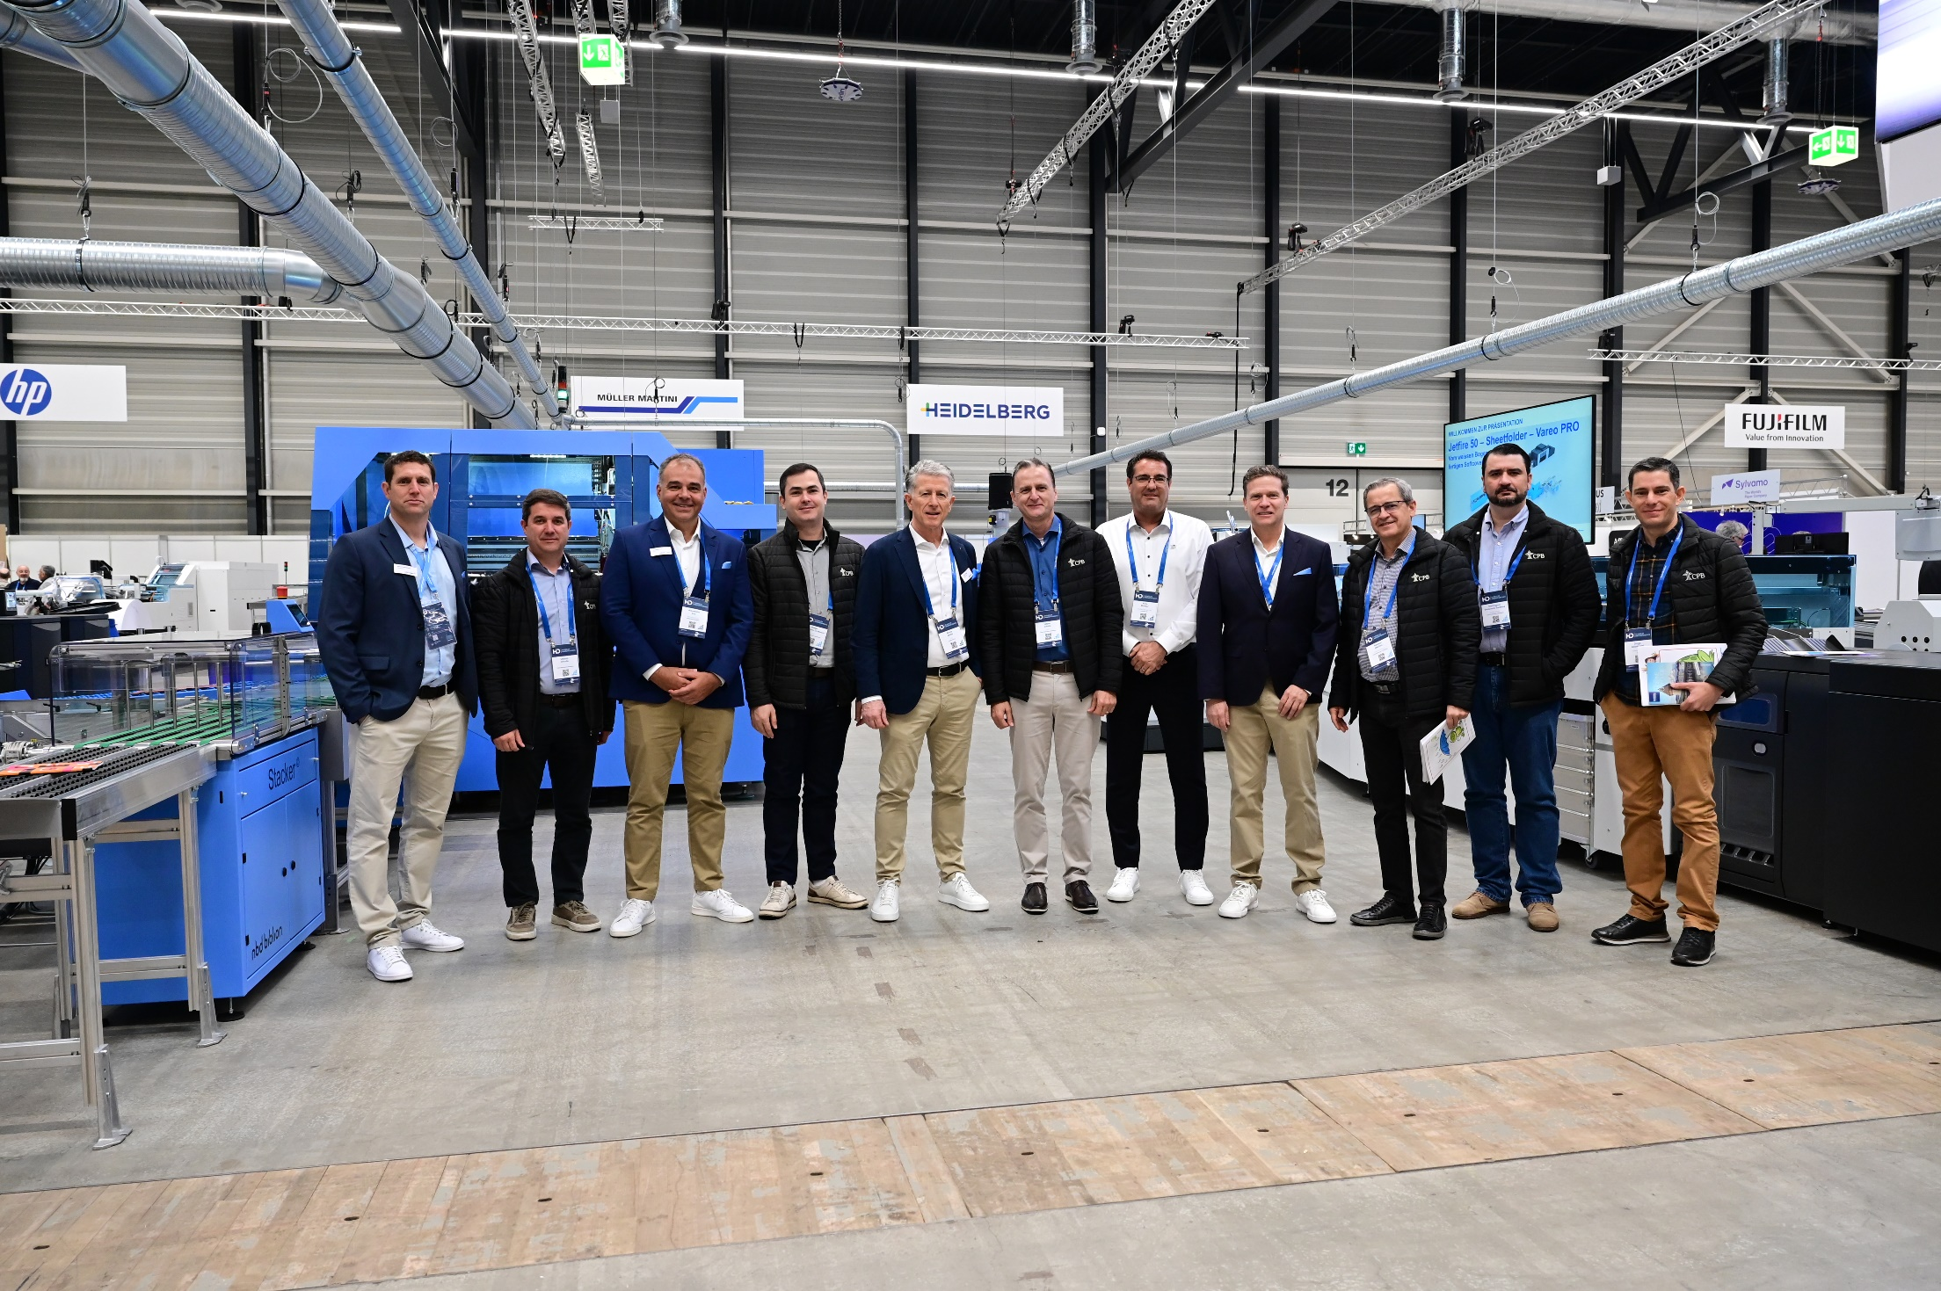
Ulison Garcia, president of Casa Publicadora Brasileira (center), caught up on the latest developments in digital printing at the Hunkeler Innovationdays. He and his team also visited the Muller Martini booth, where they were greeted by Bruno Müller, CEO of Muller Martini (5th from left).

CPB has a modern machine park with an Alegro perfect binder, a hardcover line with an RF 700 spine gluing and backstripping machine and a Diamant bookline, as well as two Primera saddle stitchers from Muller Martini. Uilson Garcia emphasized the long-standing collaboration: “We have been working with Muller Martini for over 40 years. Their products are crucial to the success of our business.”

Uilson Garcia's visit to Hunkeler Innovationdays underscores Muller Martini's close collaboration and commitment to meeting the needs of its customers in an ever-evolving industry.

