Media Information

Date 07.05.2024
No. PI 2403
Number of characters 4950
Contact Müller Martini AG
Untere Brühlstrasse 17, 4800 Zofingen/Switzerland
Phone +41 62 745 45 45
info@mullermartini.com, www.mullermartini.com

Müller Martini is a Source of Ideas, an Implementer, and an Advisor

Forward-looking management, innovative top technology, well-trained and motivated employees: These three concepts are key to Müller Martini's spirit and success and are therefore a decisive driver of the digital transformation. In drupa booth 1B50, this Swiss family-owned company will present itself as a source of ideas, an implementer, and an advisor.

Forward-looking management means, says Volker Leonhardt, member of the Group management at Müller Martini and responsible for Global Sales, “that we at Müller Martini think in decades instead of quarters, something that is typical for an owner-operated company. This thinking also affects our advising expertise, something that is becoming increasingly important. We work with customers to answer important questions and seek long-term, sustainable solutions in goal-oriented fashion.”

According to Roland Kost, Technical Director at Müller Martini, innovative top technology means “that we anticipate technological trends early on and transform these into marketable machines. Here we always focus on the changes to print products. Since we have served the graphic design industry for decades, we don’t react to market developments, but instead we act and assist our customers with their new market requirements.”
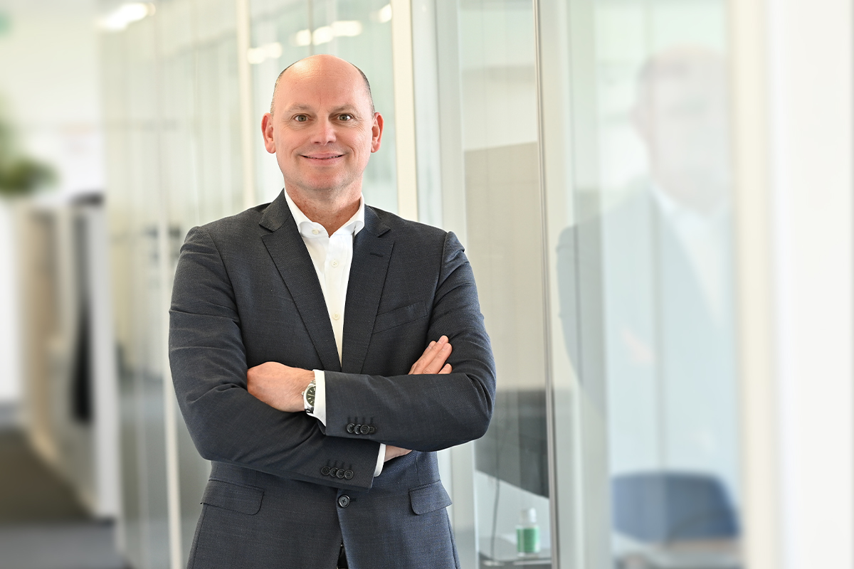
Volker Leonhardt, member of the Group management at Müller Martini and responsible for Global Sales: "At Müller Martini, we think in decades instead of quarters."

Extensive experience thanks to a global footprint

A typical example of this is the SigmaLine. 20 years ago, at drupa 2004, Müller Martini was the first company to present a unique and innovative complete solution for book-on-demand production. This system for the economical production of small(est) print runs has been developed constantly. The SigmaLine III was launched in 2021, and a few months ago, the SigmaLine Compact book block production system was added to the portfolio as an another member of the SigmaLine family. “With it, we can serve the market even better and address even more customer requirements,” emphasizes Volker Leonhardt.

If finishing 4.0 systems make up about 50% of the company's sales today, this is due not least to Müller Martini's global footprint. The USA is the leader in digital production. “The experience we have gained there,” says Roland Kost, “benefits many other projects. We have a broad and varied customer structure – from large printers to smaller family-owned operations, and from bookbinders to logistics companies. We have different approaches for all of them, in line with our motto ‘your strong partner.’”

Searching for sustainable solutions in goal-oriented fashion
In exchange with its customers, Müller Martini is not just a source of ideas and an implementer, but also an advisor. Advising has become much more important in recent years. According to Volker Leonhardt, the questions are always the same in the end: “What motivates the customer? What keeps him up at night? Where are his pain points? How can Müller Martini help overcome these?

Müller Martini works with customers to answer these questions and search in goal-oriented fashion for sustainable solutions. Roland Kost: “Because Müller Martini has frequently served its customers for decades, the company has developed profound knowledge, thanks not least to its longtime employees. Of course, the many positive reports motivate them and increase their enjoyment of their work.”

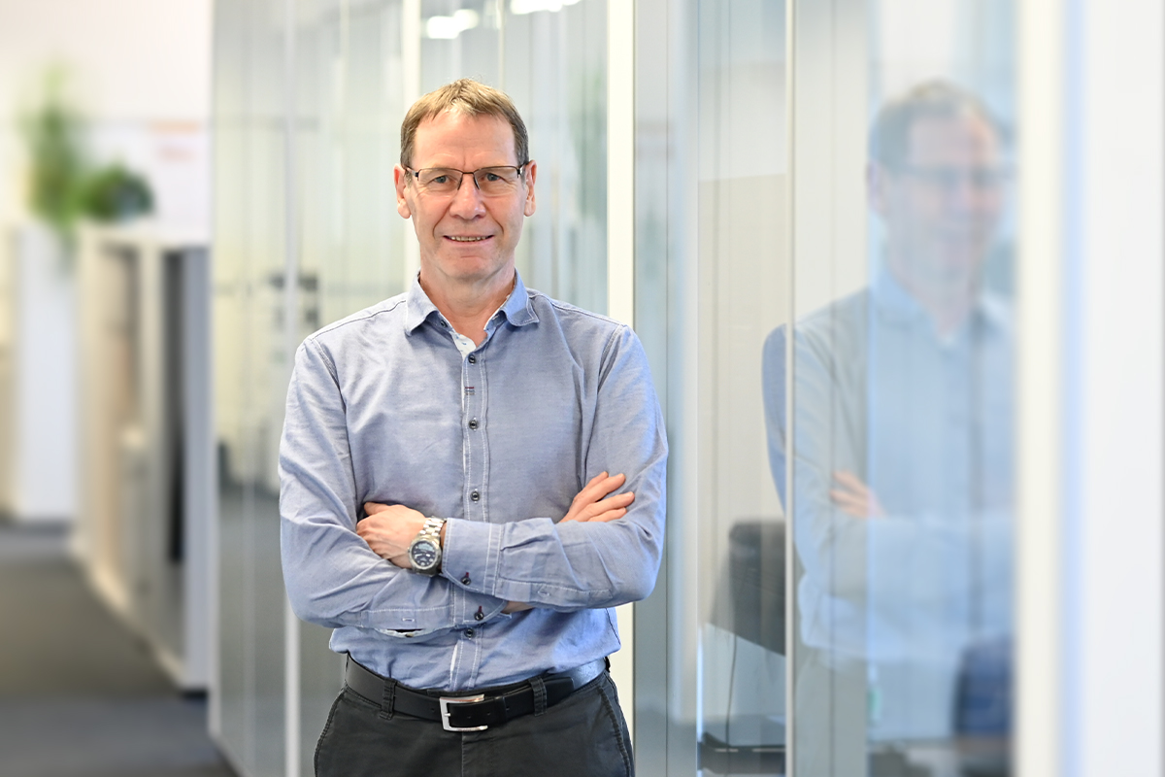

Roland Kost, Technical Director at Müller Martini: "Since we have served the graphic design industry for decades, we don’t react to market developments, but instead we act and assist our customers with their new market requirements."

Change, challenge, and opportunity

Essential for the pleasure factor are also the new market challenges, namely the digital transformation. Volker Leonhardt emphasizes, “It is a change, a challenge, and an opportunity for our salespeople, and it requires lifelong learning. Because business has definitely become more complex, our salespeople always have to remain up to date and especially understand the workflow.”

Room for employees to grow

Forward-looking management and innovative top technology are one factor, well-trained and motivated employees the other. “At Müller Martini we don’t have soldiers, but rather Samurais – that is, employees who have been walking through fire for us for decades,” says Volker Leonhardt. “Or course this has a positive effect on the corporate climate.”

Müller Martini’s culture is characterized by short decision-making paths, flat hierarchies, and no airs and graces. The company makes space so that its employees can grow and ensures that it's possible to balance work and family for an optimal work-life balance. The fact that Müller Martini has been named the best employer in the Swiss mechanical engineering sector for the second time proves that satisfaction is high at our company.

