Media Information

Date 01/23/2025

No. PI 2472

Number of characters 3280

Contact Müller Martini AG

Untere Brühlstrasse 17, 4800 Zofingen/Switzerland

Phone +41 62 745 45 45

info@mullermartini.com, www.mullermartini.com

Hunkeler Innovationdays 2025

Müller Martini at the HID 2025 – Partnerships for Exciting Solutions

**At the** [**Hunkeler Innovationdays 2025**](https://www.innovationdays.com/event/d0079c84-a78c-4d82-b469-1dce18258d7f/summary)**, which will take place in Lucerne from February 24 to 27, 2025, Müller Martini and Hunkeler will present exciting solutions that harness the full potential of digital printing. In this inspiring environment, trade visitors will learn about innovative approaches that will revolutionize their production processes.**

**Innovative solutions for smart factories**

At its own booth, Müller Martini will present three outstanding solutions for smart factories. These solutions combine the strengths of different partners, opening up new, undreamt-of possibilities that meet the requirements of the modern printing industry. Visitors can look forward to impressive applications demonstrating the flexibility and efficiency of a smart factory.

**Inline production from the white signature to the finished softcover book...**

One highlight at the Müller Martini booth will be an inline solution for producing softcover books from white signatures in different formats and thicknesses. In cooperation with Heidelberg, the [Jetfire 50 printing press](https://www.innovationdays.com/event/d0079c84-a78c-4d82-b469-1dce18258d7f/summary) will be presented, working in combination with the [Starbook Sheetfolder from Hunkeler](https://www.innovationdays.com/event/d0079c84-a78c-4d82-b469-1dce18258d7f/summary) and the [Vareo PRO perfect binder](https://www.innovationdays.com/event/d0079c84-a78c-4d82-b469-1dce18258d7f/summary) as well as the [InfiniTrim trimming robot](https://www.mullermartini.com/en/products-en/softcover-production/trimming/infinitrim/). This solution is characterized by minimal operating effort, efficient production processes and a wide variety of possible applications.

**... and from the white roll to the finished softcover book!**

In addition, another inline application will be presented, highlighting the process from the white roll to the finished softcover book. The product travels from the unprinted roll through the [HP Advantage 2200 digital web press](https://www.hp.com/de-de/commercial-industrial-printing/pagewide/a2200-hd-web-presses.html) and the [Starbook Plowfolder from Hunkeler](https://www.hunkeler.ch/en/solutions/starbook-plowfolder-book-solution/), and is then finished on the [Vareo PRO perfect binder](https://www.mullermartini.com/en/products-en/softcover-production/perfect-binding/vareo-pro/) and the [InfiniTrim trimming robot](https://www.mullermartini.com/en/products-en/softcover-production/trimming/infinitrim/). Designed for minimal staffing, this powerful production line enables efficient production of softcover books right from the white roller.

**Saddle stitching: Flexible production**

The highly automated [Prinova Digital saddle stitcher](https://www.mullermartini.com/en/products-en/digital-solutions/digital-saddle-stitching-systems/prinova-digital/) will also be presented as part of the Hunkeler Innovationdays. This hybrid solution is ideal for the efficient, low-cost production of magazines, brochures and catalogs in small print runs. The Prinova Digital enables ultra-short setup times, offering an intuitive operating concept for maximum user-friendliness.

**Connex workflow system – efficiency and customization**

Müller Martini will present its [Connex workflow system](https://www.mullermartini.com/en/products-en/) as a key technology for the efficient, cost-effective production of customized and variable print products. The system controls all the solutions shown and ensures seamless integration of all production steps, from imposition of the print data to sorting of the finished products. Müller Martini will showcase the wide range of possibilities of the workflow system as well as the entire range of MMServices.

**Unique opportunity**

The Hunkeler Innovationdays 2025 offer a unique opportunity to experience the latest developments in digital print technology and to discuss with experts. Müller Martini invites anyone interested to get to know these three innovative solutions for smart factories in live demonstrations at the booth. You can sign up for the trade fair at [mullermartini.com/hid25](https://www.mullermartini.com/en/products-en/)

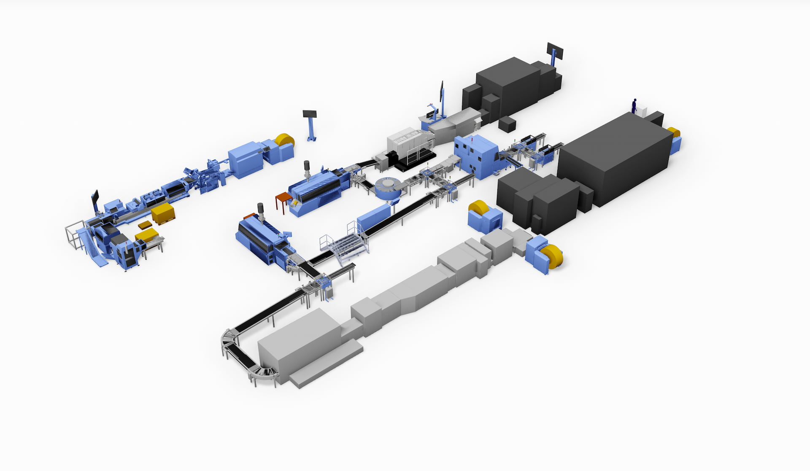

*At the HID 2025, Müller Martini will combine the strengths of different partners, presenting three unique solutions at its booth: first, from the white roller and second, from the white signature to the finished softcover book and third, highly automated saddle stitching production.*