Media information

Date 12.05.2025
No. PI 2489
Number of characters 1884
Contact us Muller Martini AG
Untere Brühlstrasse 17, 4800 Zofingen/Switzerland
Phone +41 62 745 45 45
info@mullermartini.com, www.mullermartini.com

Muller Martini at China Print 2025: Experience Innovations up Close

It's almost time! We look forward to welcoming you to China Print 2025 between May 15 and 19! Visit us at our booth E1-010 in the New China International Exhibition Center in Beijing and experience the latest Muller Martini innovations.

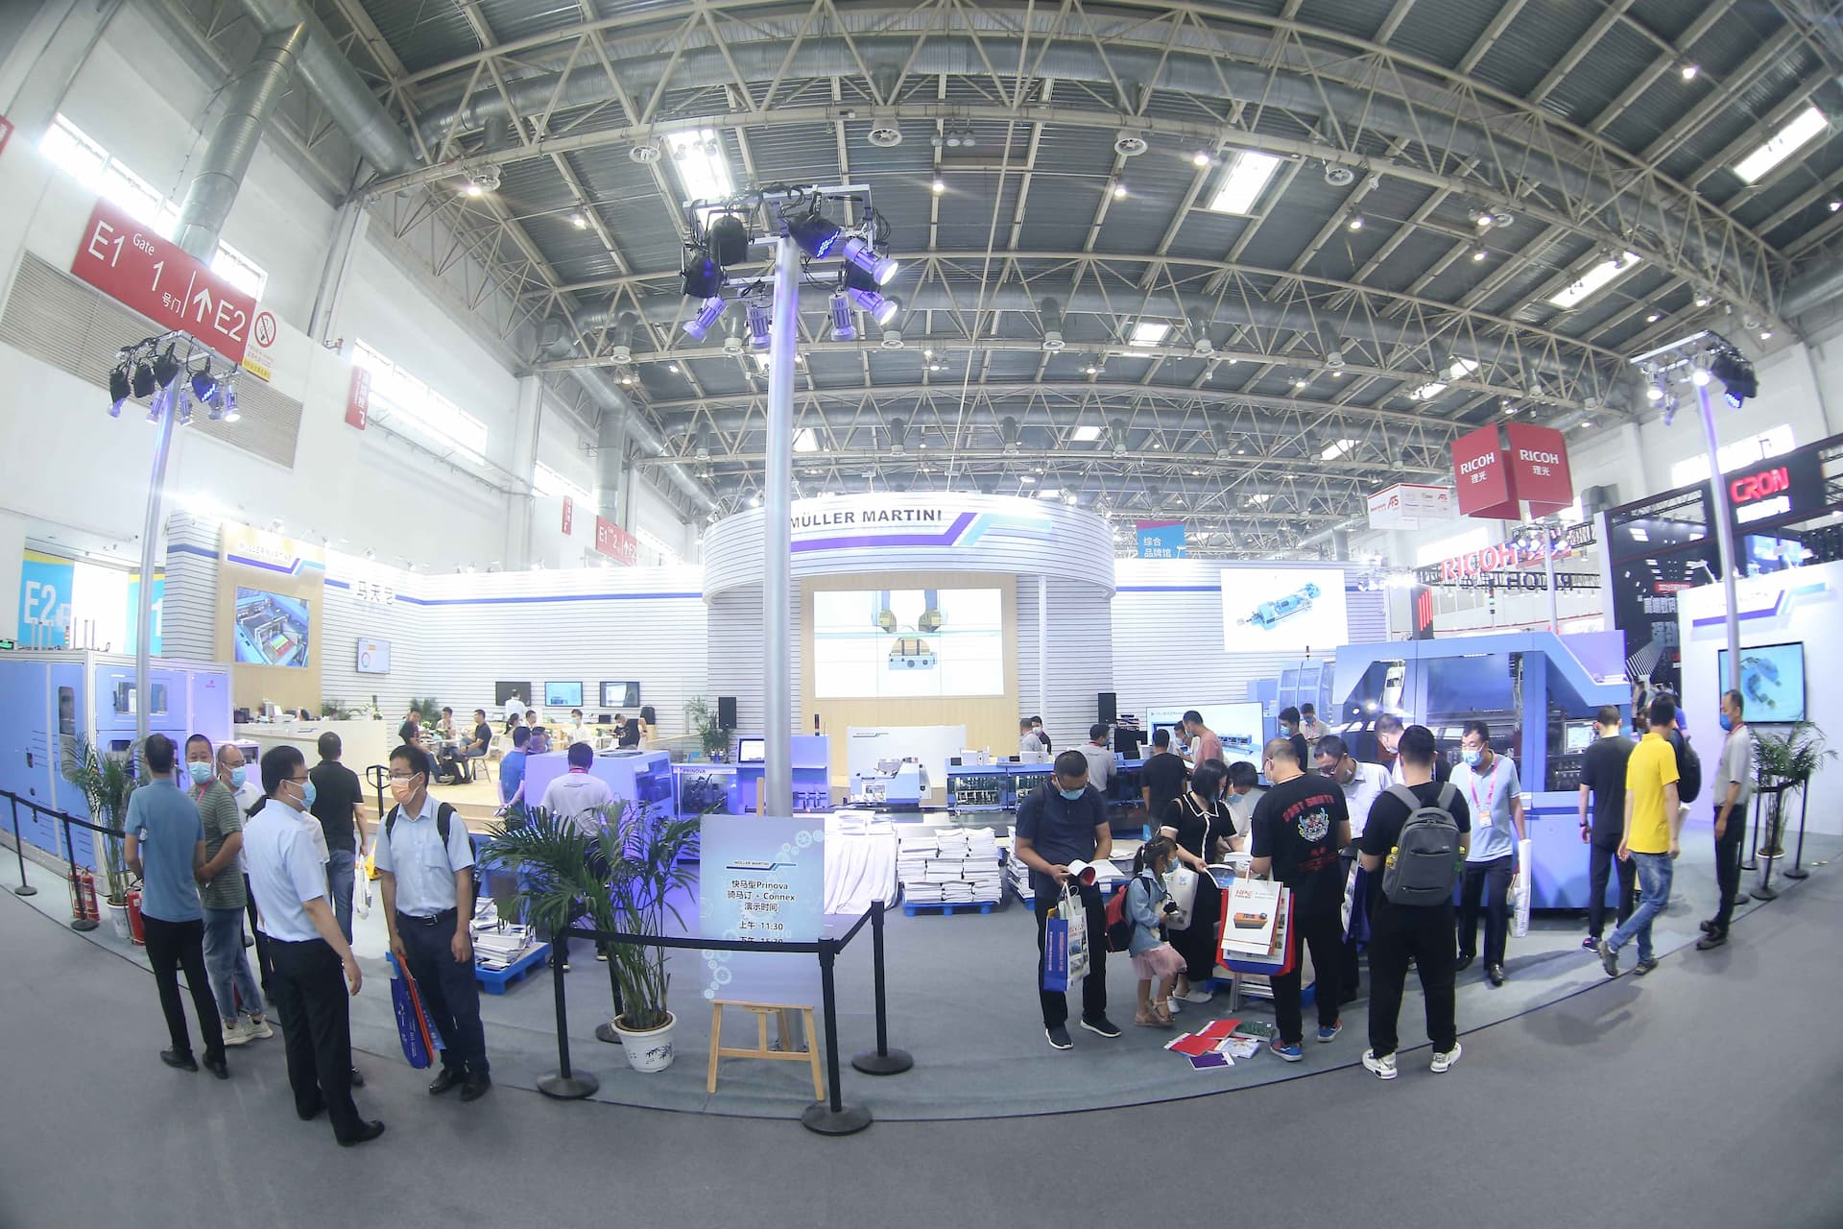

Our highlights at China Print 2025

SigmaLine Compact: This state-of-the-art book block line sets new standards in book production. With its compact design and impressive efficiency, it is the perfect solution for flexible and economical production processes. The SigmaLine Compact enables seamless integration into existing production environments and offers a high degree of adaptability to different job sizes and requirements.

Vareo PRO with InfiniTrim: The Vareo PRO perfect binder, combined with the revolutionary InfiniTrim cutting robot, offers an unbeatable combination of precision and speed. This machine is ideal for producing high-quality, perfectly cut books and brochures in short runs. The Vareo PRO is characterized by its ease of use and high production reliability, while the InfiniTrim ensures precise and clean cuts.

Generation 8 roll-to-stack solution from Hunkeler: This versatile solution for the finishing of printed rolls impresses with its reliability and flexibility. The Generation 8 roll-to-stack solution from Hunkeler is the perfect addition to any print shop that demands the highest quality and efficiency. With its ability to process a wide variety of paper types and formats, it offers high production flexibility.

Take this opportunity to learn firsthand about the latest developments in printing and finishing technology and gain valuable insights into the future of the industry.

We look forward to seeing you there and to exciting discussions! Together, we are shaping the future of the printing industry.

Müller Martini – Your strong partner.

