Press Release

Date 10.12.2020
No. PI 2277
Number of characters 6055
Contact Muller Martini AG
Untere Brühlstrasse 17, 4800 Zofingen, Switzerland
Phone +41(0)62 745 45 45
info@mullermartini.com, www.mullermartini.com

Perfect binder Vareo PRO – the perfect solution
for offset and digital production

As a compact all-rounder, the newly developed Vareo PRO from Muller Martini is the perfect solution for finishing specialists and printers who use conventional printing processes or are active in digital printing.

The three-clamp perfect binder, which achieves 1350 cycles per hour, is based on the well-known Vareo and has numerous new features to optimize the production. For example, the new Vareo PRO features a unique operating concept developed in line with the latest ergonomic aspects, with a new graphical user interface for perfect interaction between man and machine.

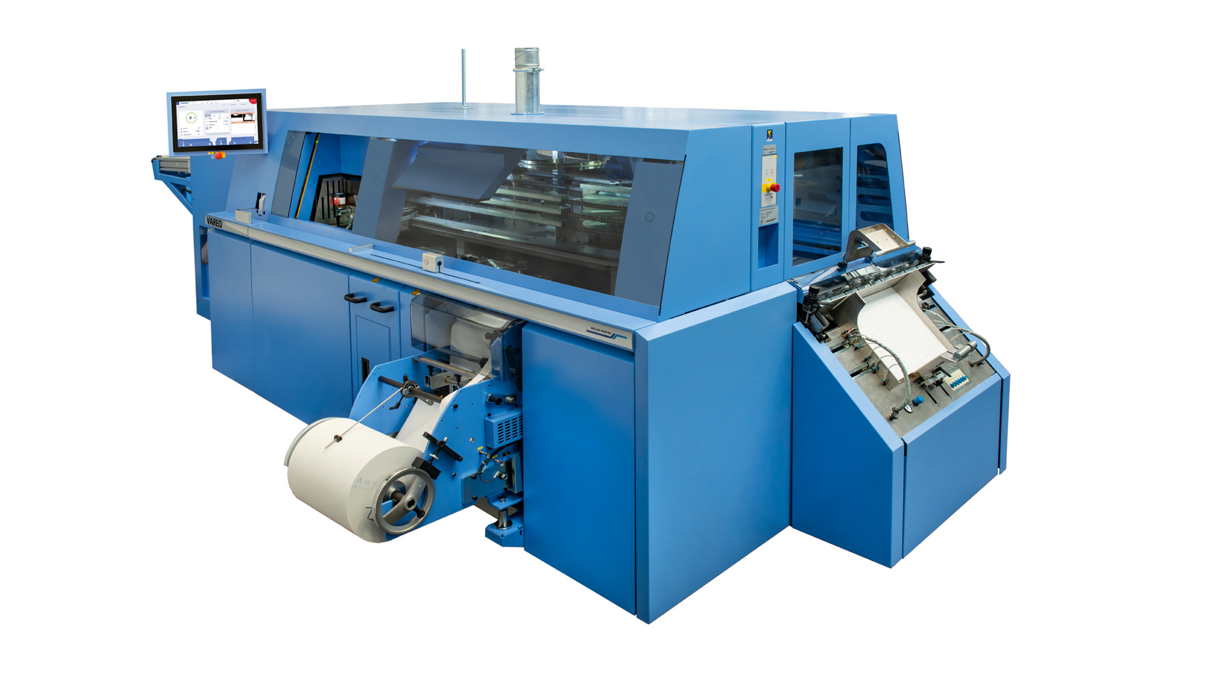
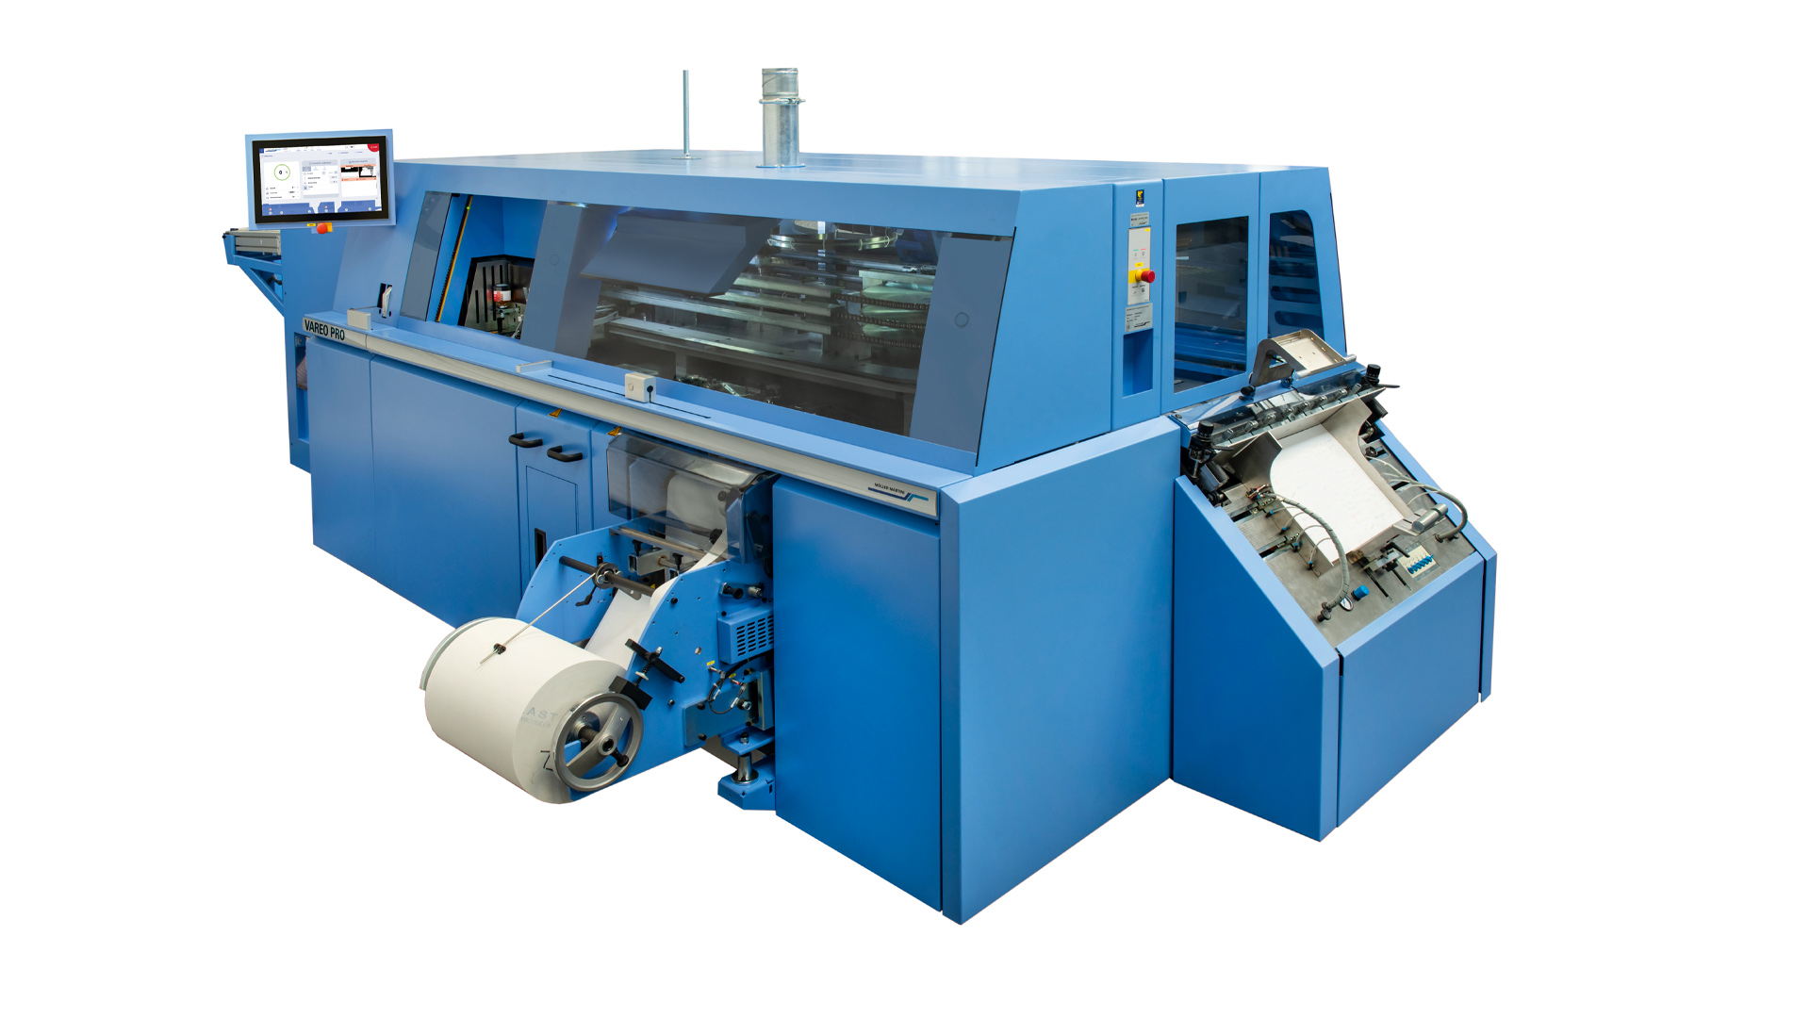
The Vareo PRO has a unique operating concept with a new graphical user interface for perfect interaction between man and machine.

On the 18½ inch touchscreen with a clearly structured menu navigation including animation of corrections, the operator sees all important production parameters at a glance and has quick access to all stations. The intuitive user interface allows extremely short changeover and production times. In addition, the latest state-of-the-art control technology from B&R ensures high performance and availability of all electrical components.

Fully automatic edge gluing
Compared to the predecessor model Vareo, the hotmelt back gluing unit of the Vareo PRO has also been revised. Like the PUR back gluing unit, the hotmelt system is also available with an optional trolley, making the two systems easy, reliable and, thanks to a separately available preheating cable, interchangeable without any loss of time. The hotmelt spine gluing system, which is based on the Alegro 7000 cycle perfect binder from Muller Martini, has been completely redesigned to ensure ideal glue flow and temperature control. It is equipped with two application rollers and a separately heated counter-rotating spinner roller. The two roller systems are now independently height adjustable.

Edge gluing is now fully automatic as standard. All settings are thus reproducible. With a volume of 5 or 18 liters, the Robatech pre-melters, which are optimal for the respective application, can be configured separately. The design updates will further improve processing in the field of book-of-one production in particular.

New PUR nozzle system and new glue application control
The production of very short runs down to book 1 with constantly changing block thicknesses, even with higher quality perfects such as PUR, is becoming increasingly important. This is accompanied by the demand for more efficient use of PUR glue. In order to guarantee glue application without glue loss with monitoring for top quality, especially in the ultra-short run and book-of-one sector, Muller Martini developed a completely new PUR nozzle system and a new glue application control system for the Vareo PRO.

The optional PUR nozzle system with volumetric circulation system guarantees perfect glue application and reliable binding with a wide range of materials, regardless of pressure, temperature and viscosity. A fully format-variable nozzle head ensures perfect and loss-free spine glue application from book to book. The PUR nozzle system can be cleaned and maintained extremely quickly and easily. This results in up to 20 percent higher productivity. Costs are also lower because less glue is needed if the PUR nozzle is used efficiently.

An optional optical glue application monitoring system is also available in conjunction with the PUR nozzle. The completely newly developed, laser/camera-based monitoring system, which is equipped with new algorithms for even more accurate detection of a defect image, ensures greater reliability in glue application. Both the quantitative (glue present or not) and the qualitative control (glue layer thickness, edge gluing) are displayed in 2D and 3D on the touch screen.

Connection to Connex LineControl
In addition to Connex.Info, the monitoring and reporting tool of the Connex workflow system, the Vareo PRO can also be connected to Connex LineControl in the future if required. This enables the perfect binder to be integrated into a higher-level planning system (MIS/MES) via a digital job ticket (JDF). All relevant production control data is taken from the JDF file, prepared for the connected production line and then transferred to the production line. This greatly reduces the organizational effort that the operator has to make in his daily work. Job data such as run length, job name or format are available directly at the press without manual input by the operator. This also ensures data quality throughout the entire production process. In addition, Connex LineControl offers options for integrating barcode scanners for job activation and error detection.

Duo with InfiniTrim, Trio with VBA/InfiniTrim
The Vareo PRO unfolds its full potential in – in line with Muller Martini's Finishing 4.0 philosophy and especially for ultra short runs – as a duo with the InfiniTrim three-knife trimmer. With its unique cutting concept, this trimmer cuts short and very short runs down to book 1 with all book sizes and thicknesses fully automatically – both in manually loaded solo operation and in inline mode. For medium runs, a combination with the Granit three-knife trimmer is also suitable. Its innovative SmartPress technology enables highly cost-effective production in a wide range of applications.

The duo can even become a trio: Together with the Vareo PRO and InfiniTrim, the end sheet feeder is the dream team for industrial inline or nearline production of hardcover books in run length 1.

In addition, each Vareo line can be extended to form a cell. Muller Martini has successfully installed extensions with up to four Vareo PROs in an InfiniTrim. Extensions in the direction of hardcover book block production are just as easily possible. If later expansion requests are known, this can be taken into account during the layout creation in the first phase.

