Press Release

Date 03.11.2020
No. PI 2262
Number of characters 2210
Contact Muller Martini AG
Untere Brühlstrasse 17, 4800 Zofingen, Switzerland
Phone +41(0)62 745 45 45
info@mullermartini.com, www.mullermartini.com

Printing Expo: Visit the Virtual Muller Martini Showroom Without Having to Travel!

Muller Martini will be represented as a Premium Partner with a virtual showroom at the Printing Expo Virtual Exhibition, the first virtual exhibition in the graphic arts industry, which goes online on November 30 at 9.30 am GMT.

"The digital transformation – and this development was undoubtedly accelerated by the Corona crisis – is not stopping at the graphic arts industry," says Adrian Mayr, Head of Product Management & Corporate Marketing at Muller Martini. "I consider the Printing Expo an interesting format to fill a vacuum created by the presence events that were cancelled due to the pandemic.”
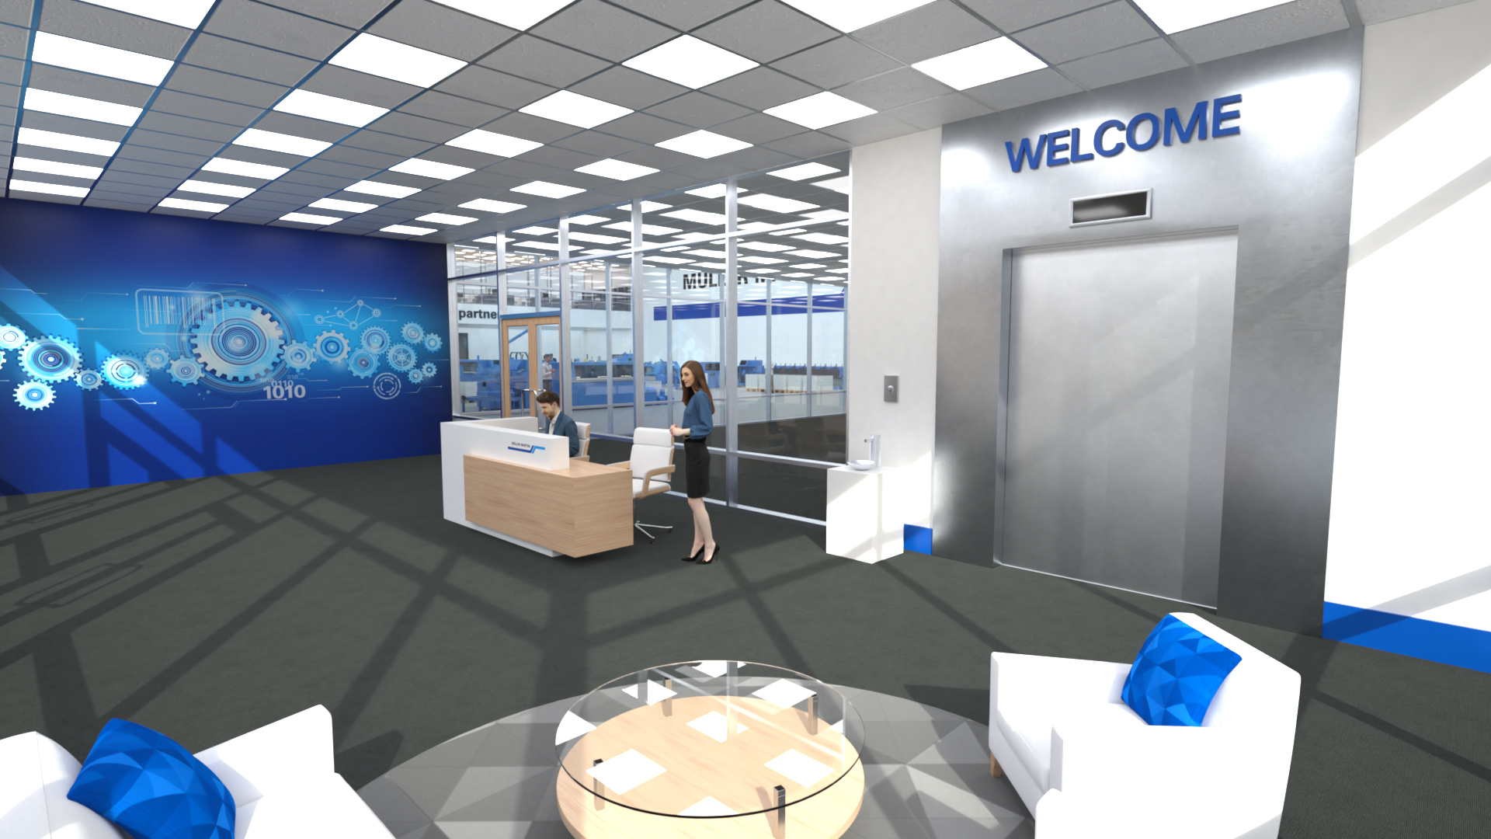
The Muller Martini showroom at Printing Expo is open 24 hours a day, 365 days a year and can be visited free of charge.

No sooner said than done: As a Premium Partner, Muller Martini invites its customers and other interested parties to its virtual showroom, which is open 24 hours a day, seven days a week, from next Monday onwards – without the hassle of traveling and whenever they have time. There you will find a lot of information on the recently launched Prinova and Primera PRO saddle stitchers. A complete perfect binding line with an end sheet feeder, Vareo perfect binder and InfiniTrim three-knife trimmer will also be presented virtually.

The 3D machine presentations will be supplemented by information on workflow solutions and the range of services offered by Muller Martini. In the following weeks, Muller Martini will successively add more machines virtually – with the aim of presenting all those systems that should have been demonstrated live at the cancelled drupa 2020.

"For Muller Martini, the Printing Expo, as the virtual meeting place of our industry, is an ideal additional channel for presenting its solutions in an attractive way," emphasizes Adrian Mayr. "We can convey such valuable added value as videos, presentations, brochures and data sheets. Visitors, who can easily navigate back and forth between the various exhibits and machine manufacturers, are thus provided with virtually the same information as at a conventional exhibition stand.”

