Press Release

Date 15.12.2020
No. PI 2271
Number of characters 2504
Contact Muller Martini AG
Untere Brühlstrasse 17, 4800 Zofingen, Switzerland
Phone +41(0)62 745 45 45
info@mullermartini.com, www.mullermartini.com

Reduce the Spine Build up With

the New Spine Nipping Press VFN 700

The new VFN 700 spine nipping press from Muller Martini presses each book block in the spine area, thereby significantly reducing the spine build up. In this way, bookbinders can achieve a very good book block shape for all common paper types with their different characteristics.

In the manufacturing process of hardcover products, the spine build up of the book blocks caused by the folding process and resulting from thread sewing is a well-known phenomenon. This does not only lead to problems in downstream processes but can also have a negative effect on the quality of the product – key words are glue penetration into the book block and uneven glue application. To counteract this problem, book producers often use simple manual or semi-automatic presses. However, this generates an additional step in the manufacturing process and is therefore not efficient. With the new VFN 700 inline-capable, 30 cycles per minute spine nipping press, Muller Martini has the right answer to this challenge.

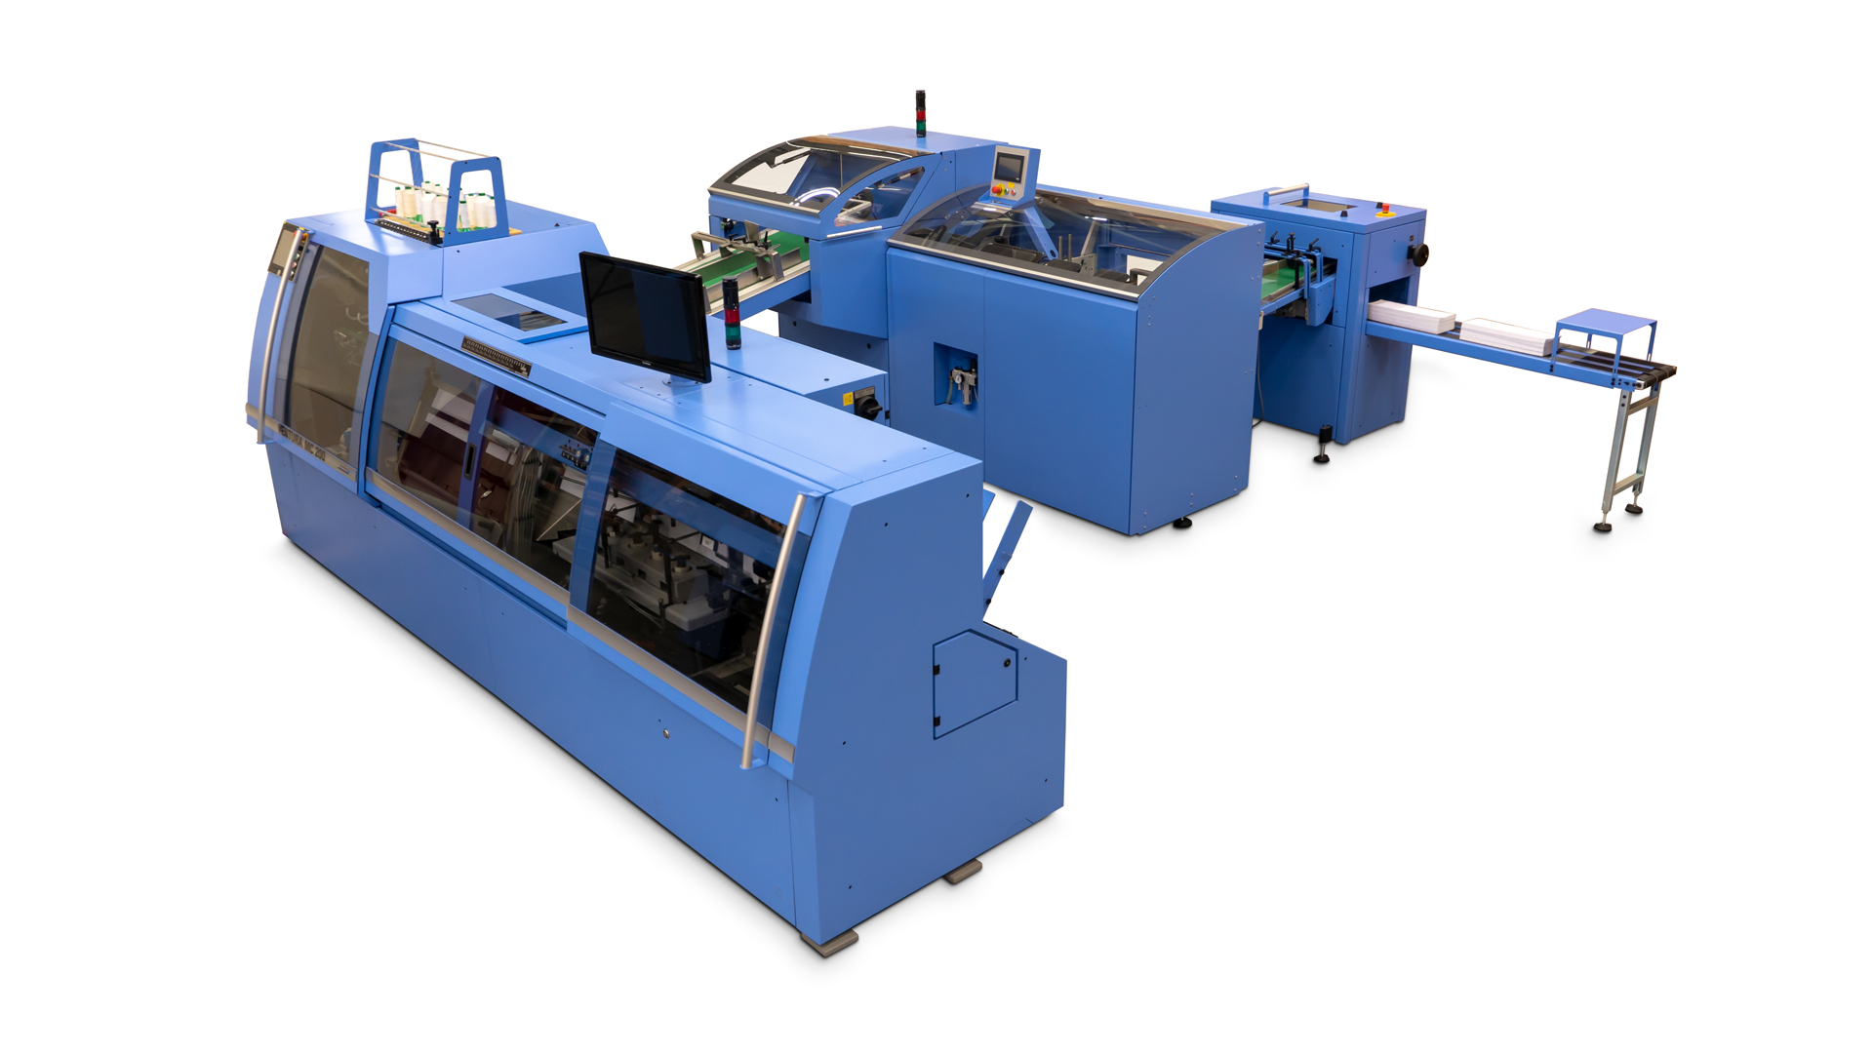

The VFN 700 from Muller Martini is the right answer to the spine build up of the book blocks that occurs during book sewing.

With the VFN 700, each book block is pressed in the spine area, which significantly reduces the spine build up. In this way a very good bookblock shape is achieved with all common paper types with their different characteristics. The pressing force is generated with the help of a pneumatic cylinder according to the toggle lever principle, resulting in a pressing force of up to 60 kN. The spring-loaded pretensioning clamps hold the book block in place and by that prevent the deformation of the book spine.

The VFN 700 has been designed for all conventional thread sewing applications and is therefore available in three versions. For an inline production using a Ventura Connect system or a Ventura MC 160/200 including a stacker and belt delivery, a respective variant is available and can be configured individually. The VFN 700 can also be configured offline – i.e. as a stand-alone machine – and can be loaded manually with book blocks from various book sewing machines.

Three operating modes complete the machine and make it possible to cover every case of application. If the VFN 700 is not needed, it can pass through the book blocks unpressed in "bypass mode". In "automatic mode" the bookblocks are pressed after a preset pressing time, while in "press & hold mode" each bookblock is pressed until the next one arrives.

