Press Release

Date 03.11.2020
No. PI 2262
Number of characters 3621
Contact Muller Martini AG
Untere Brühlstrasse 17, 4800 Zofingen, Switzerland
Phone +41(0)62 745 45 45
info@mullermartini.com, www.mullermartini.com

Stitch Quickly, Efficiently and Profitably with the New Primera PRO

In order to be able to stitch high-volume standard products efficiently and inexpensively in addition to house specialties, Schär Druckverarbeitung AG, located in Wikon (canton of Lucerne), is commencing operations this fall of Muller Martini’s new Primera PRO saddle stitcher.

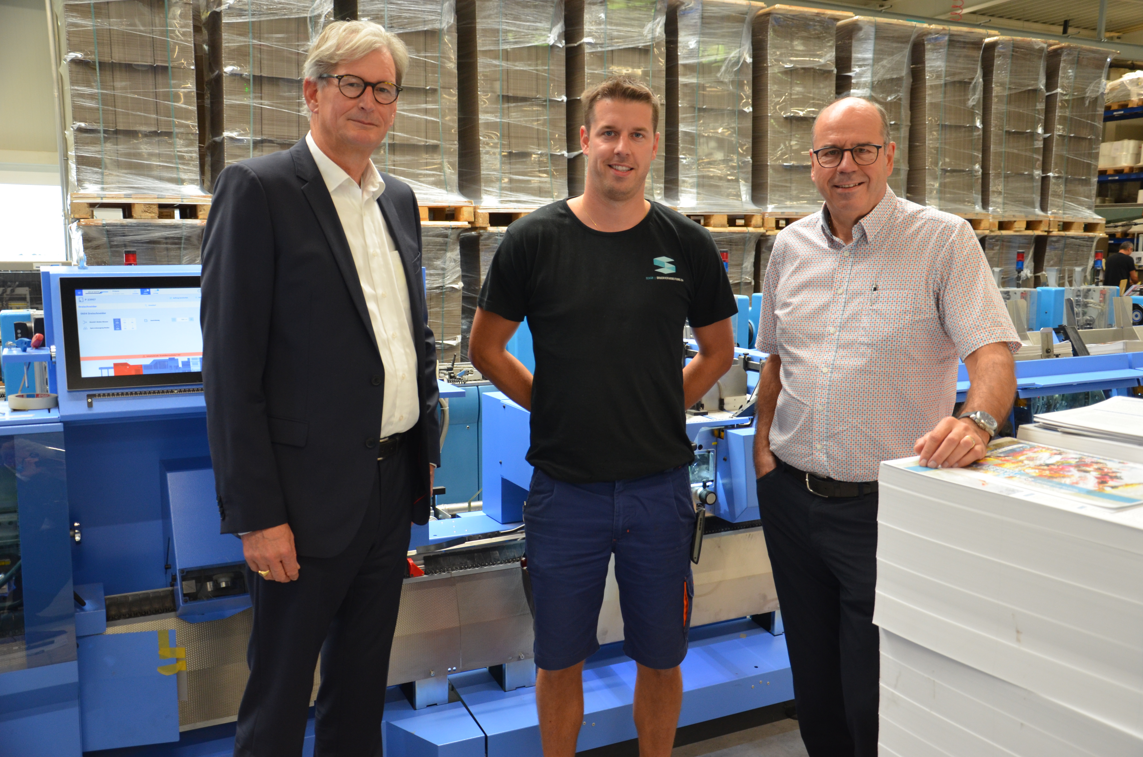
Extremely small or large products with contour die cutting, all possible forms of folding (including mini folds) thanks to a wide variety of machines, inline rotary die cutting in one pass, including labeling and gluing, pocket folders and diaries in all possible forms, personalized one-page or two-page self-mailers with glued-in inserts, small-folded brochures – the list of special products offered by Schär Druckverarbeitung AG in addition to traditional saddle-stitched brochures and timetables with runs ranging from 500 to several million copies is extensive. “There’s a trend toward special and eye-catching products,” says Paul Bucher, the Chairman of the Board. “But, of course, we also need solutions for stitching high-volume standard products efficiently and inexpensively.”
Paul Bucher (right, Chairman of the Board) and Yannick Bucher (center, Managing Director) chose the new Primera PRO saddle stitcher. Richard Hofer (left, Sales Manager at Muller Martini).

That’s why the successful family company, which focuses on print finishing, invested in Muller Martini’s recently introduced 14,000-cycle Primera PRO saddle stitcher – as a replacement for its 221 machine and an addition to its Primera S Amrys and a 235 machine. “The original idea,” says Yannick Bucher, who manages the company together with his sister Marina, “was to replace the 221 and 235 machines with the Primera PRO in order to do more with less. But since the new premises we moved into three years ago had enough room we decided to keep the 235 for the time being.”

Schär opted for the Primera PRO, which includes a new user interface with a larger touchscreen, in particular because of its innovative Motion Control Technology. This reduces setup and processing times for orders significantly and ensures the highest level of profitability. “This technology, the machine’s fast, stable production and the ability to fine-tune on the fly had me convinced when I saw the demonstration of the predecessor Primera MC at the Muller Martini Print Finishing Center,” says Yannick Bucher. In addition to its high cycle speed, there are two other advantages to the Primera PRO: its large size variability (especially important for A3 products) and the proximity between Schär and the Muller Martini plant – just a few kilometers.

In addition to the significant expansion of the automation, which enables even faster and easier changeovers and setup processes, the completely new three-knife trimmer is another highlight. It runs fully automatically and no manual intervention is required for setup.

Schär Druckverarbeitung AG, which has nearly 60 employees and mainly serves customers throughout Switzerland, commenced operations of its new Primera PRO with six flat pile feeder, a cover feeder and four stream feeders for efficient signature feeding, in September. It is networked with the existing peripheral systems of the two other saddle stitchers.

Company boss Paul Bucher, who completed training at Muller Martini many years ago, is confident that his company has increased its market opportunities, performance and flexibility with its new investment. “But that doesn’t change the fact that we have to produce at a low cost – after all, price is everything when it comes to saddle stitching.”

