Press Release

Date 14.01.2021
No. PI 2261
Number of characters 1991
Contact Muller Martini AG
Untere Brühlstrasse 17, 4800 Zofingen, Switzerland
Phone +41(0)62 745 45 45
info@mullermartini.com, www.mullermartini.com

Cartoedit Saves Taxes Thanks to Its New Saddle Stitcher

Based on years of good experience with two perfect binders and a saddle stitcher from Muller Martini, Cartoedit in Castello Perugia, Italy, invested in a new Primera MC saddle stitcher – and is enjoying tax benefits as a result.

The recently installed Primera MC is used at Cartoedit for countless jobs in the medium and long run ranges. The extensive product range includes school books, fiction books, dictionaries and art books, as well as comics, magazines and calendars. "Our philosophy has always been to be able to offer our customers high-quality products with a technically first-class machine park," says company owner Lucio Ciarabelli.
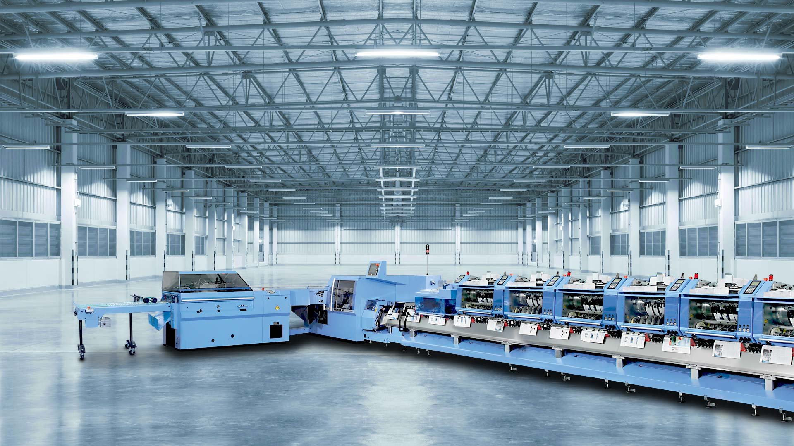
The Primera MC impresses at Cartoedit with its high level of automation and, thanks to its Finishing 4.0 standard, also brings the company tax benefits.

The new Primera MC continues a long tradition with Muller Martini machines at the complete graphic arts company, which was founded in 1972 and employs 95 people, with prepress, press, postpress and shipping. For years, a Prima saddle stitcher and two Trendbinder perfect binders from Muller Martini have been providing successful service.

The Primera MC, which produces at 14,000 cycles per hour, is not only quickly set up and ready for production, but also guarantees that all products are perfectly stitched thanks to its comprehensive quality controls. "This was an important aspect in our investment decision," emphasizes Lucio Ciarabelli. Add to this, according to the company patron, "the training of our employees by Muller Martini technicians has done a lot to optimize the performance of the saddle stitcher."

Another key factor in the installation of the Primera MC is the associated tax benefits offered by the Italian government when companies invest in machines in line with Industry 4.0 standards. "And the new saddle stitcher easily meets these requirements with its Finishing 4.0 philosophy," emphasizes Lucio Ciarabelli.

