Press Release

Date 05.08.2020
No. PI 2257
Number of characters 3196
Contact Müller Martini AG
Untere Brühlstrasse 17, 4800 Zofingen/Schweiz
Telefon +41 62 745 45 45
info@mullermartini.com, www.mullermartini.com
Goebel Capital GmbH
Schochenmühlestr. 4, 6340 Baar/Schweiz
Rothenburgstrasse 34, 6274 Eschenbach LU/Schweiz
Telefon +41 41 700 90 18
info@goebel-capital.com, www.goebel-capital.com

Muller Martini Sells MM Druckmaschinen GmbH in Maulburg to the Goebel Group

Six years after suspending the production of variable size web printing presses, Muller Martini is selling MM Druckmaschinen GmbH, located in Maulburg, Germany, to Goebel Capital GmbH, in Baar/Eschenbach, Switzerland. The company will now be known as Goebel MMD GmbH. As a result, Muller Martini printing press customers will not only receive support over the long term, they will also benefit from the latest developments by Goebel.

Muller Martini suspended production of variable size web printing presses in 2014, focusing the Maulburg location on the service business for the over 1,000 web printing presses installed around the world. Muller Martini is now selling MM Druckmaschinen GmbH in Maulburg to the Goebel Group “With Goebel, we have found a partner that is strategically positioned over the long term in this area, one that offers both services and new machines,” says Bruno Müller, CEO of Muller Martini.

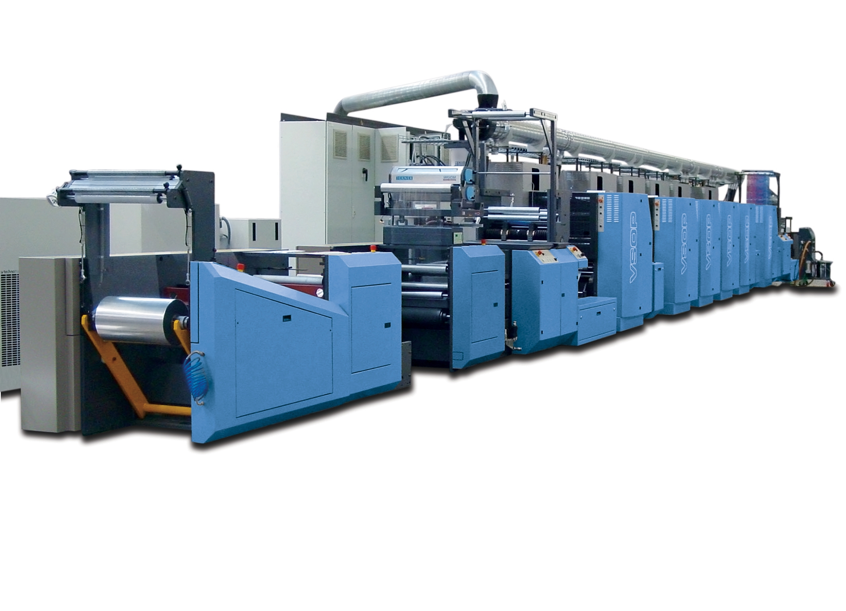
Muller Martini will ensure the availability of spare parts for the large number of installed web printing presses (pictured: a variable size VSOP) over the coming years.

With its modern product range, the Goebel Group was Muller Martini’s preferred candidate. According to Felix Berg (COO Goebel Group), there was fundamental and mutual interest in the transaction. “The agreement with Muller Martini allows us to provide services and spare parts to existing printing press customers over the long term while also enabling them to invest in the latest Goebel technology.”

Customers will continue to receive support locally by Muller Martini sales and service organizations. With respect to the sale of new machines, retrofits, extensions, service and spare parts, these organizations will be supported by long-term employees in Maulburg, who will continue to be fully employed by Goebel MMD GmbH.

Under the agreement, Muller Martini will in the future serve as the exclusive intermediary for the sale of Goebel printing presses in the area of package printing and security printing while offering service and continuing to provide spare parts over the coming years. “This will allow us to continue to offer our printing press customers the best support,” says Bruno Müller.

About Muller Martini
Muller Martini, a family-owned business established in 1946, has its head office in Zofingen in the Swiss canton of Aargau. With some 1,200 employees worldwide, the company is involved in the development and production of industrial system solutions for print finishing.
www.mullermartini.com

About Goebel
The family company, which was founded in 1851, now has its headquarters in Baar, located in the Swiss canton of Zug, with branches and subsidiaries in Eschenbach, Switzerland (canton of Lucerne) and the German cities of Darmstadt and Maulburg. It is one of the world’s leading companies in the area of package printing (web offset) and security printing (intaglio, offset and hybrid printing systems).
www.goebel-capital.com

Further Information
Felix Stirnimann, Member of the Board of Directors of Muller Martini: Phone +41 (0)62 745 47 70.
Dr. Manuel Vogel, CEO of the Goebel Group: Phone +41 (0)41 700 90 18.

