Press Release

Date 12.03.2020
No. PI 2236
Number of characters 2140
Contact Muller Martini AG
Untere Brühlstrasse 17, 4800 Zofingen, Switzerland
Tel. +41 (0)62 745 45 45
info@mullermartini.com, www.mullermartini.com

Too Good to Google

John Good Ltd., located in the English city of Rugby, specializes in programs. With a new Primera MC saddle stitcher from Muller Martini the company now produces even faster than before.

Anyone pulling out their mobile phone during a theater performance to google an actor or an author is bound to get some dirty looks. Often, it is more useful to put all of the important information about a play in a program. When this is done for a show in London’s West End, the theater-goer is likely to have a John Good Ltd. product in their hands. With an annual print run of 6 million copies, the long-standing graphic arts company is the UK's largest producer and publisher of theater programs. Since replacing a Primera C130 with a Primera MC, the company has seen substantially higher productivity – 45 percent higher for long runs.
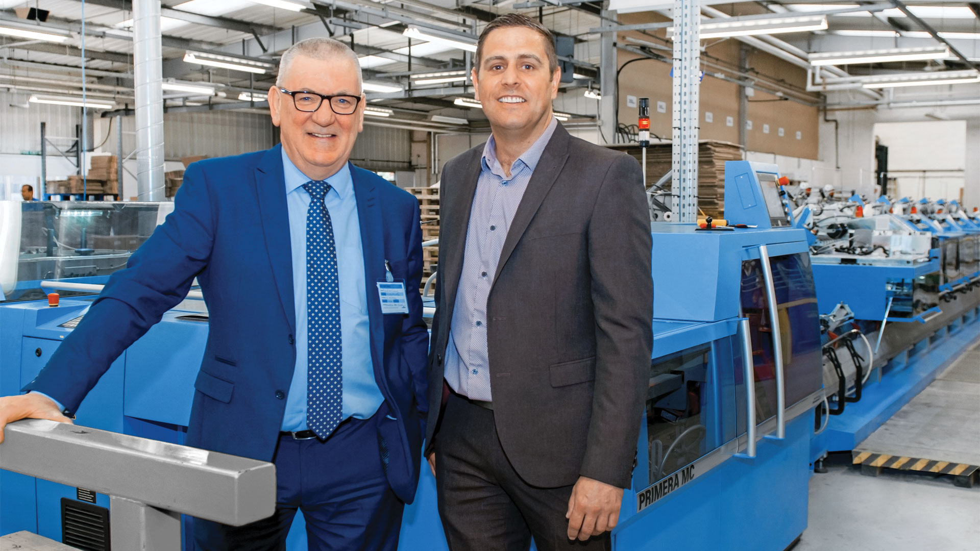
Simon McKay (right), Operations Director at John Good Ltd., is impressed with the higher productivity thanks to the new Primera MC saddle stitcher. Left: David McGinlay, Sales Manager at Muller Martini Great Britain.

“We used to be able to produce an average of 6,500 brochures per hour. Now, it’s at least 10,000,” says Simon McKay, citing an example of the increase in productivity the company has experienced. McKay, the Operations Director at John Good Ltd., also notes that the company has reached the machine’s maximum capacity, with long runs of 14,000 cycles per hour. Every week, the company produces 35 to 40 different programs with runs of between 300 and 300,000 copies and anywhere from 28 to 60 pages on the Primera MC with a cover feeder, six flat pile feeders, stream feeders and a Perfetto compensating stacker.

The company, which was founded by John Good in the 1980s, runs 24 hours a day, six days a week, and is not limited to printing – in most cases, it also serves as a general contractor of sorts, with responsibility for design, texts, image selection, advertisements and distribution. The high-quality programs have a lot of sentimental value for collectors, not least because they often include added value features such as UV coating, coated covers, foils or flip boxes.

