Press Release

Date 12.02.2020
No. PI 2234
Number of characters 2318
Contact Muller Martini AG
Untere Brühlstrasse 17, 4800 Zofingen, Switzerland
Tel. +41 (0)62 745 45 45
www.mullermartini.com

“Two-for-One” Investment

Thanks to its investment in a new Kolbus brand KM 610.A perfect binding line from Muller Martini, Diversified Global Graphics Groups (DG3), located in Jersey City (New Jersey, USA), has increased its softcover production by 60 percent.

The production of annual reports is one of the core business areas of the globally active company. In its own annual report for 2019, DG3 will probably not be short on praise for the acquisition of the perfect binder. This is because the KM 610.A with a 16-station ZU 805 gathering machine, HD 143.P three-knife trimmer and KL 301 compensating stacker, which was installed just eleven weeks after the contract was signed, has reduced processing times significantly, especially during the reporting season in the first quarter of last year. It was the ideal response to the increase in short-run jobs, which have risen as the importance of digital printing has grown.

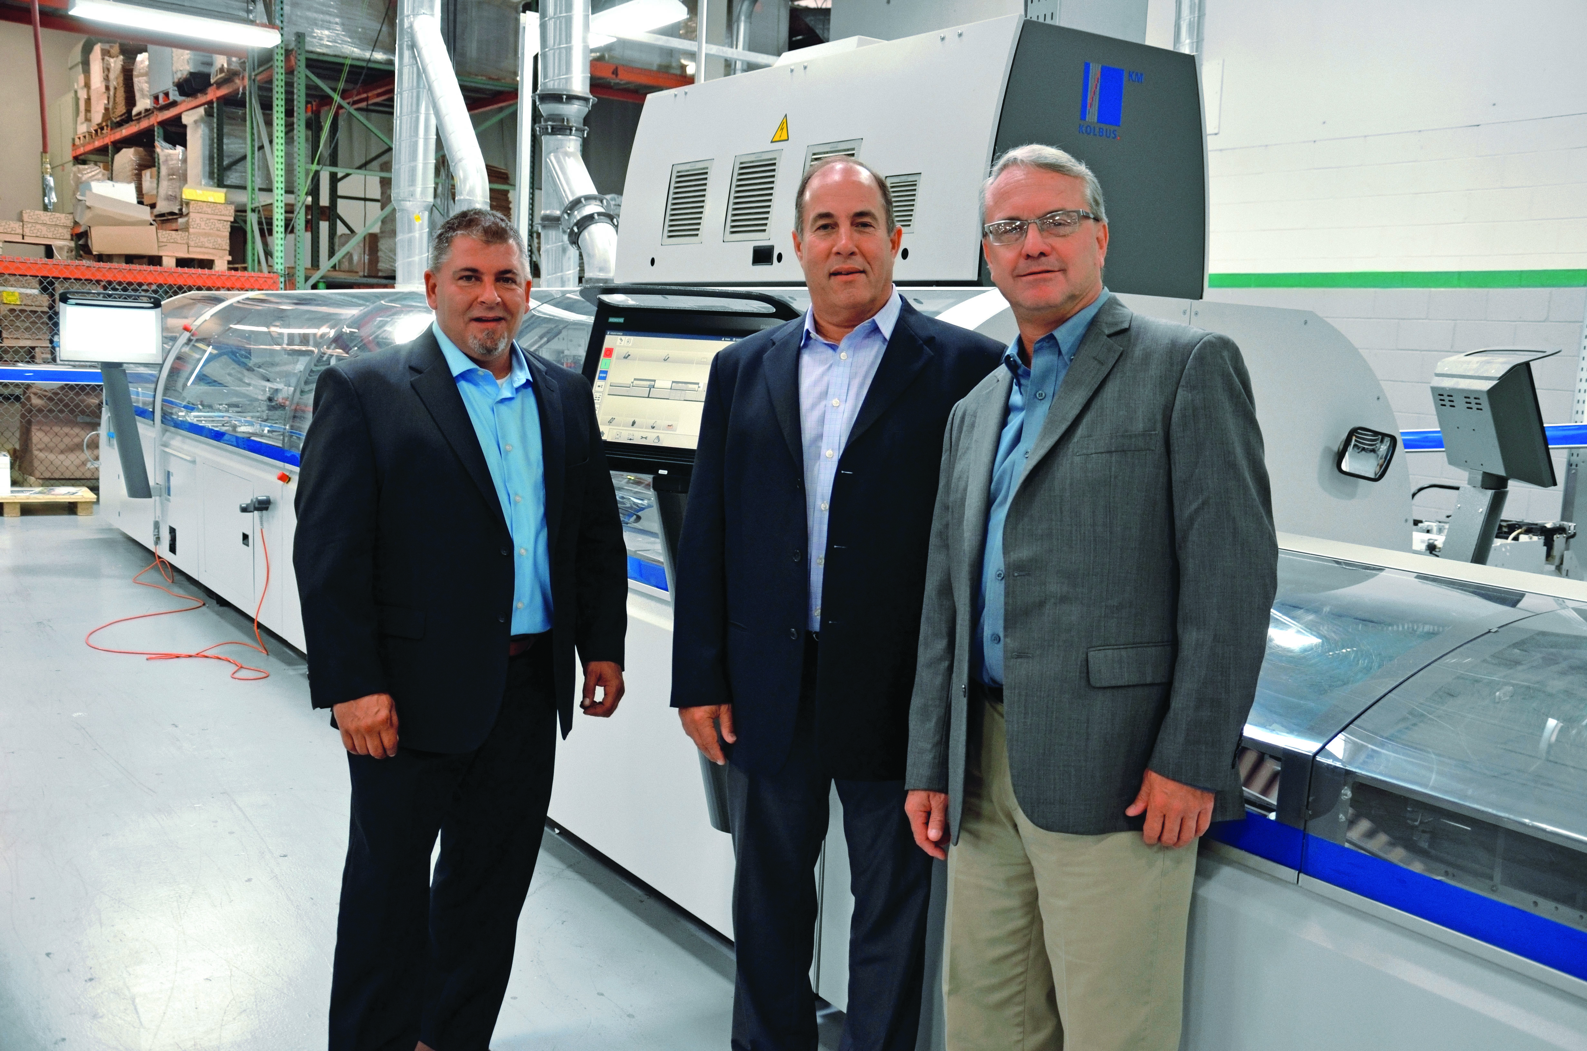

It only took eleven weeks after the contract was signed for the DG3 KM 610.A perfect binder to commence operations. From left: Patrick Caragliana, Steven Babat (both of DG3) and Frank Donnelly (Sales Manager at Muller Martini North America).

Although annual reports, with runs of at least 1,000 copies and a total print run of four million per year, are an important business segment for the Jersey City facility, which operates 24 hours a day, seven days a week, its 365 employees do not work exclusively with print products. DG3 also offers its customer electronic channels. “We don’t sell our customers individual products, but rather holistic solutions,” says CEO Steven Babat. This is because multi-channel communication is becoming ever more important. Long-term partnerships have paid off in other business segments as well, such as pharmaceuticals and commercial work.

The new KM 610.A perfect binding line at DG3 replaced two older perfect binders from another manufacturer, with one of these machines kept in reserve as a backup solution. The “two-for-one” investment quickly proved to be the perfect one for the innovative company. Over the past year, softcover output has risen by 60 percent. This sharp increase was not only due to the generally more efficient production process. Many customers also appreciate that DG3 – thanks to the KM 610.A – can now offer PUR binding as well.

