Medien-Information

Datum 26.11.2020
Nr. PI 2276
Anzahl Zeichen 276
Kontakt Müller Martini AG
Untere Brühlstrasse 17, 4800 Zofingen/Schweiz
Telefon +41 62 745 45 45
info@mullermartini.com, www.mullermartini.com

Volker Leonhardt talk guest at INKISH-TV

INKISH-TV, the online TV channel for and about the printing industry with videos about people, events, companies, business and technologies, regularly features well-known personalities from the graphic arts industry. In the latest interview, Andreas Weber, CEO INKISH DACH (Germany/Austria/Switzerland), talks to Volker Leonhardt, member of the Muller Martini Group Management and responsible for global sales, about current challenges in print finishing.

"The printing industry measures itself all too closely against developments in printing technology," says moderator Andreas Weber in his introduction. “However, in the end it is the finishing process that determines the quality, excellence and effectiveness of print production.” According to Volker Leonhardt, Muller Martini has the right answers to precisely these questions.

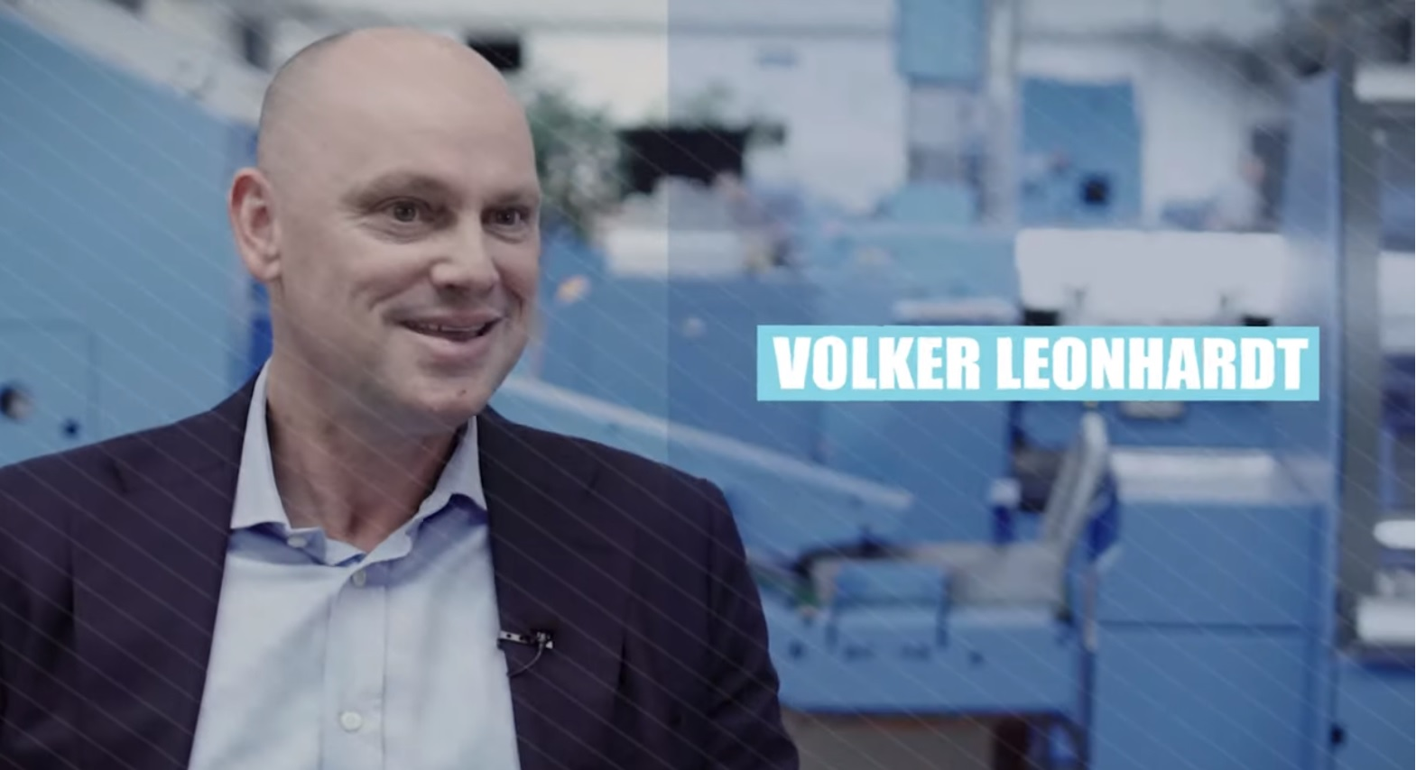
Smart Factory, VDP production, Book-of-One, Connex workflow system – in an interview with INKISH TV, Volker Leonhardt shows how Muller Martini customers can target new markets with Finishing 4.0 solutions.

In the interview, which lasts around 20 minutes and is conducted in English with German subtitles, he shows how Muller Martini, with its motto Finishing 4.0, has evolved from a manufacturer of systems designed for mass production to the leading supplier of finishing solutions in the digital printing sector and thus also for new target markets. According to Volker Leonhardt, the keywords are Smart Factory, VDP production, Book-of-One and the Connex workflow system developed by Muller Martini, which networks processes, links the various systems together and allows the production status of a job to be seen at any time.

In this interesting TV talk by Andreas Weber with Volker Leonhardt, immerse yourself in the exciting world of digital transformation in the graphic arts industry – have fun!

