Media information

Datum 14.10.2021
Nr. PI 2311
Anzahl Zeichen 2104
Kontakt Müller Martini AG
Untere Brühlstrasse 17, 4800 Zofingen/Schweiz
Telefon +41 62 745 45 45
info@mullermartini.com, www.mullermartini.com

Productivity increased by 50 percent

4bind Ltd in Stevenage, England, which is part of the 4books Group, has achieved two goals at once after commissioning a Vareo perfect binder and a VBA 3683 end sheet feeder from Muller Martini. Firstly, it significantly improved their competitiveness for slightly higher runs of book production. Secondly, the bindery increased its hardcover and softcover productivity by 50 percent compared to their previous solution.

Founded in 2015 by David Button and Nigel Wood, 4bind, which employs six people, works primarily with UK printers. It specializes in the production of hardcover and soft cover books in the lower and medium run segments.

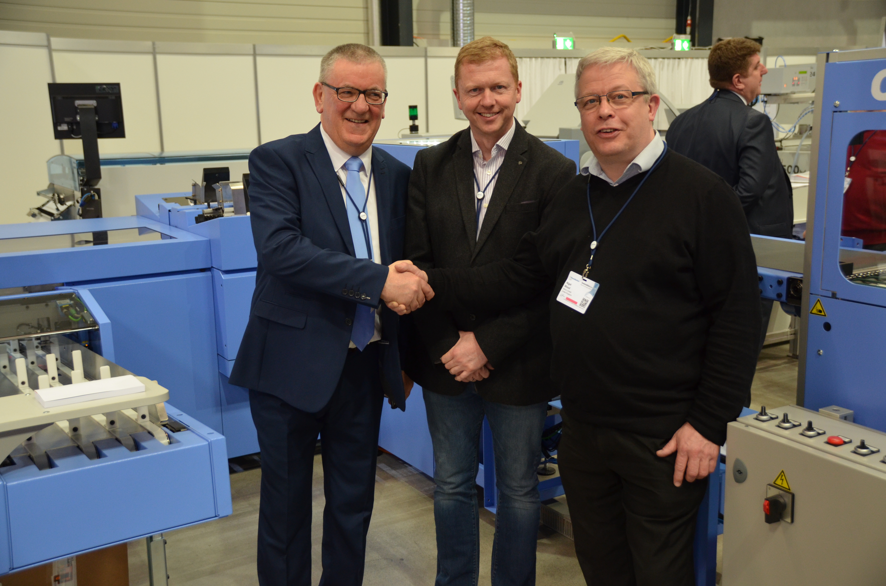
Dave Button, Managing Director 4bind Ltd (center), Nigel Wood, Production Director 4bind Ltd (right), and David McGinlay, Sales Manager Muller Martini UK, seal the sale of the Vareo and VBA.

4bind invested in a Vareo and VBA to improve efficiency and quality of their bound books. "Our goal was to optimize our workflow with the three-clamp perfect binder including in-line end sheeting" said Dave Button. "Productivity has increased over 50 percent, allowing us to increase the number of books we can bind each day and also allowing us to increase run lengths. We are very pleased with the Vareo installation."

With its new solution, 4bind, like all graphic arts companies, has suffered for months from the corona crisis, but since the summer has again seen an increase in orders. Despite considerably higher raw material costs, 4bind have improved their market opportunities, particularly in the medium run segment.

Short run printing and perfect binding is the responsibility of sister company 4edge Ltd, based in Hockley and finishes its book production with an InfiniTrim three-knife trimmer from Muller Martini, one of the UK's leading independent short run producers.

In addition to the Vareo, 4bind also commissioned a VBA 3683 end sheet feeder – read this blog on the Muller Martini website. "This” says Production Director Nigel Wood, "allows us to produce hardcover and softcover books more efficiently and economically."

