Media Information

Datum 19.08.2021
Nr. PI 2307
Anzahl Zeichen 2524
Kontakt Müller Martini AG
Untere Brühlstrasse 17, 4800 Zofingen/Schweiz
Telefon +41 62 745 45 45
info@mullermartini.com, www.mullermartini.com

"We Love to Bind Books"

The Publikum print shop built a new production site on the outskirts of the Serbian capital Belgrade and invested in new finishing technology from Muller Martini as part of the project.

Since it was founded in 1989, Druckerei Publikum has experienced rapid growth and now employs 100 people. One of the triggers for the positive business development was the installation of a Diamant MC 35 bookline from Muller Martini in 2014. "Our commitment, our passion and our appreciation for publishers and books have enabled us to achieve this growth," emphasizes Managing Director Dušan Janković. This is also reflected in the company's slogan: "We Love to Print." In this context, it would probably be better to say "We Love to Bind Books".

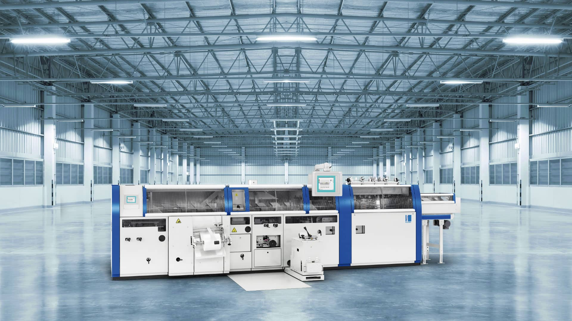

In addition to a KM 610.A perfect binder, the Publikum print shop also invested in an RF 700 spine gluing and folding machine (picture).

The company produces high-quality softcover and hardcover books for the domestic and international markets. Particularly in the case of art, cookery and children's books, as well as travel guides and graphic novels, the company simultaneously plays out its performance and competitiveness. Together with its customers, the print shop also ventures into unusual types of binding and finishing, thus also causing a stir internationally.

Due to continuous growth, the operation in the center of Belgrade was bursting at the seams, prompting Publikum to build a new building on the outskirts of the Serbian capital, which was occupied in the middle of this year. In the course of this, the technology in the print finishing department was also renewed and expanded. Capacities and application possibilities were significantly expanded – for example, by investing in a KM 610A perfect binder line from Muller Martini with inline processing of folded-in flaps and front trim.

In addition, the existing Diamant MC 35 will be supplemented by an RF 700 spine gluing and folding machine from Muller Martini, which can be used to glue and fold thread-sewn book blocks. Using the integrated attachment feed station, additional pre- and post-sets can be applied and glued to the book block before the gluing process, which again increases the process speed. The RF 700 can be designed both in book production lines and as an offline solution.

