Press Release

Date 22.04.2021
No. PI 2296
Number of characters 1917
Contact Muller Martini AG
Untere Brühlstrasse 17, 4800 Zofingen, Switzerland
Phone +41(0)62 745 45 45
info@mullermartini.com, www.mullermartini.com

SzóKép Printing: Turning Two into One

In order to optimize its softcover production, SzóKép Printing in the Hungarian capital of Budapest put a new Pantera perfect binder line from Muller Martini into operation last month.

Until now, the company, which was founded in 1996 by Olivér Szikszay and employs 48 people, used two smaller perfect binders – an Amigo from Muller Martini for hotmelt gluing and a second from another manufacturer for PUR gluing – for the approximately 1.5 million softcover products it produces each year in a wide range of formats between A6 and A4, some with a spine thickness of just 1 mm. "By only needing one machine now with the Pantera," says Olivér Szikszay, "we not only produce more economically, but also increase our softcover capacities and the quality of the end products at the same time."

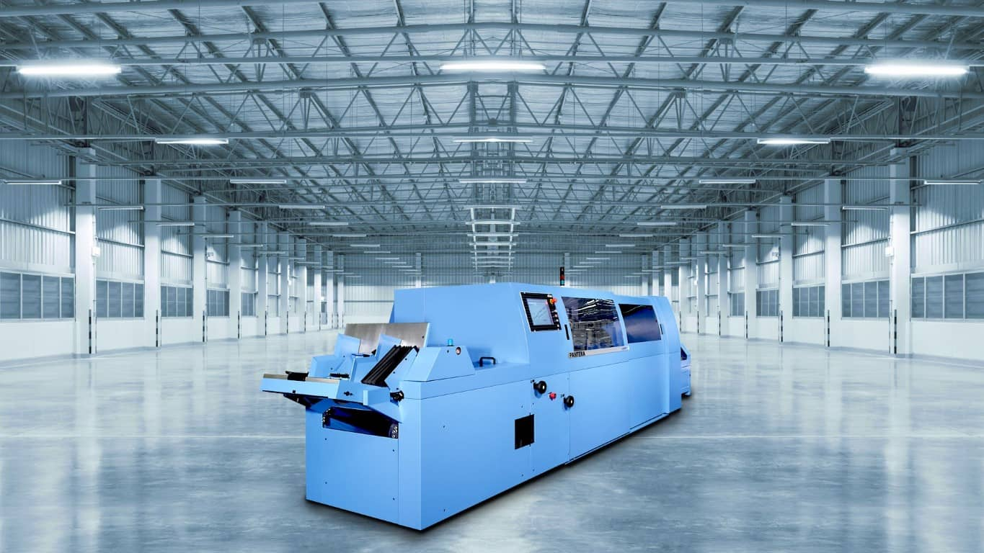
With the Pantera, SzóKép Printing not only produces more economically, but also increases its softcover capacities and the quality of the end products at the same time.

The Pantera line with a 3692 gathering machine (16 stations), hand feeder and drying tower was chosen by the full-service printing company with state-of-the-art CTP equipment, three presses and postpress firstly because of its fast make-ready and secondly because it forms an ideal duo with the Granit three-knife trimmer.

Fast make-ready times are particularly important in the family business, where three generations work, because the run lengths per job are constantly decreasing as a result of digital printing. "On the other hand, digital printing ensures," says Olivér Szikszay, "that the product range for our customers, mainly in Hungary but also abroad, grows continuously from year to year."

In addition to perfect binding, SzóKép Printing also attaches great importance to saddle stitching. The company relies on a Primera C110 from Muller Martini for the approximately 13 million products it stitches each year.

