Medien-Information

Datum 29.03.2021
Nr. PI 2292
Anzahl Zeichen 2570
Kontakt Müller Martini AG
Untere Brühlstrasse 17, 4800 Zofingen/Schweiz
Telefon +41 62 745 45 45
info@mullermartini.com, www.mullermartini.com

The FlexLiner Takes off!

Printfinish direktwerbung GmbH in the Austrian capital Vienna is expanding its capacity for inserting advertising supplements and will be installing a FlexLiner inserting system from Muller Martini for this purpose next month.

The company has been consistently expanding its range of finishing and mailing services since 2009. Today, the spectrum ranges from classic bookbinding work, inserting inserts on a large scale, foiling and addressing magazines to inserting mailings. The post-certified lettershop prepares a wide range of products for national and international mailing and sends them on their way to the recipient. In addition, PrintFinish is currently expanding its capabilities in the production of direct mailings with an innovative inkjet printing system.

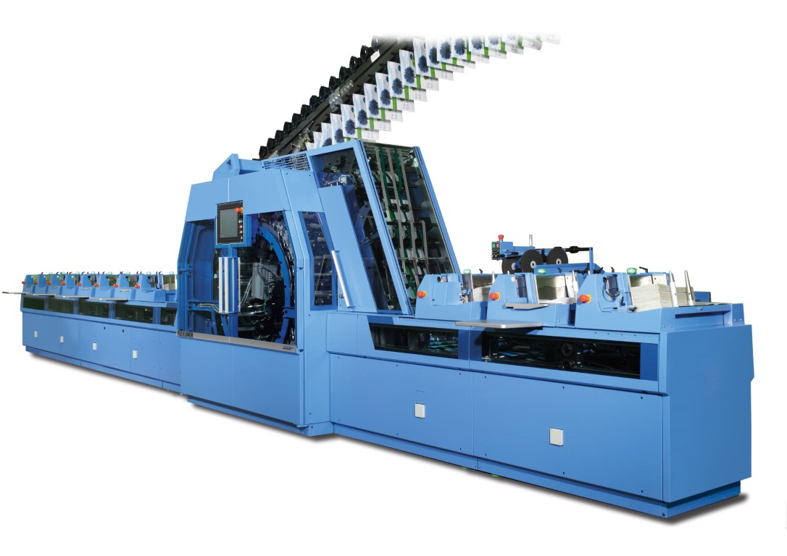

Alexander Holzer (PrintFinish Operations Manager): "The FlexLiner, with its high output of 30,000 copies per hour, helps us to meet increasingly tight deadlines."

"The current corona crisis in particular highlights once again how vulnerable cross-border supply chains can be. This is one of the reasons why we are expanding our site in Vienna," says Alexander Holzer. According to the Operations Manager, the retail sector in particular still relies heavily on unaddressed inserts in its market communications. Against this background, the company wants to position itself even more strongly as a reliable regional partner.

"In our business, efficiency and quality are the decisive factors for prevailing over the competition. The FlexLiner, with its high output of 30,000 copies per hour, helps us to meet the increasingly tight deadlines," emphasizes the operations manager. The company has already been able to gain a clear picture of the precision and reliability of Muller Martini solutions in recent years in conjunction with the AlphaLiner inserting system – the smaller brother, so to speak, of the FlexLiner, which produces at 15,000 cycles per hour.

In addition to performance, Alexander Holzer emphasizes the high degree of automation and the suction/vacuum opening of prefolderless products of the FlexLiner with Robusto compensating stacker. The opening types make it much easier to process inserts and brochures with low grammages and are therefore an important building block for efficient production in this segment. "When it comes to inserting advertising printed matter without a prefold, Muller Martini is clearly ahead with the FlexLiner," Alexander Holzer sums it up. He is already thinking about the next innovations to land lucrative orders for the company.

