Press Release

Date 18.03.2021
No. PI 2291
Number of characters 1660
contact Müller Martini AG
Untere Brühlstrasse 17, 4800 Zofingen/Schweiz
Telefon +41 62 745 45 45
info@mullermartini.com, www.mullermartini.com

The Right Perfect Binder for Eurographic Group

Eurographic Group will be installing a KM 610.M at its plant in Szczecin (Poland) in mid-2021. The management of the Danish company is particularly impressed by the attractive price/performance ratio of the new perfect binder line from Muller Martini.

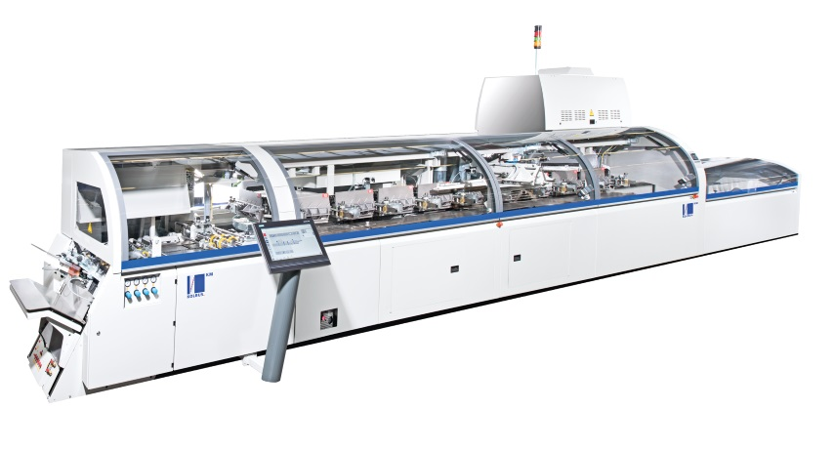
Eurographic Group has been printing exclusively digitally at its Szczecin site since it was founded in 2013 and specializes in the production of books and operating manuals in short runs. In order to expand its capacities, the company entered the B2 format in digital printing last year. With this format leap, the company abruptly improved its performance, cost structure and thus also its competitiveness.

With the new KM 610.M perfect binder, Eurographic Group in Szczecin intends to expand further.

In order to achieve these positive effects in finishing as well and to efficiently coordinate the individual systems in the entire production chain, Eurographic is now commissioning the world's first KM 610.M from Muller Martini. The company decided in favor of the new softcover line, which has a capacity of 5000 cycles per hour, not least because of its convincing price/performance ratio.

In future, Eurographic Group will not only be able to call on the quality potential of the new perfect binder, but will also benefit from its great flexibility, which is evident in the very short setup times, among other things. With the KM 610.M, Eurographic Group also brought spare capacity for further expansion into the newly built production hall. The investment package is rounded off by a Granit three-knife trimmer, which guarantees the clean cut of the books.

