Press Release

Date 11.03.2021
No. PI 2284
Number of characters 3166
Contact Müller Martini AG
Untere Brühlstrasse 17, 4800 Zofingen/Schweiz
Telefon +41 62 745 45 45
info@mullermartini.com, www.mullermartini.com

Staying à jour with two new Ventura MC 200s

To ensure its high technological standards, Grafotisak in Grude (Bosnia-Herzegovina), one of Europe's largest book producers, is replacing two older Ventura MC 200 with two new Muller Martini book sewing machines of the same type. Together, they again form a Connect system.

"It is our philosophy to always invest in the latest technology to minimize repair and maintenance costs," says Marko Vranješ. "The two Ventura MC 200s from 2013 and 2014 were still running reliably. But with the two new thread sewing machines, we are increasing our production reliability and reducing setup times," emphasizes the deputy general manager and son of company founder Stipan Vranješ.

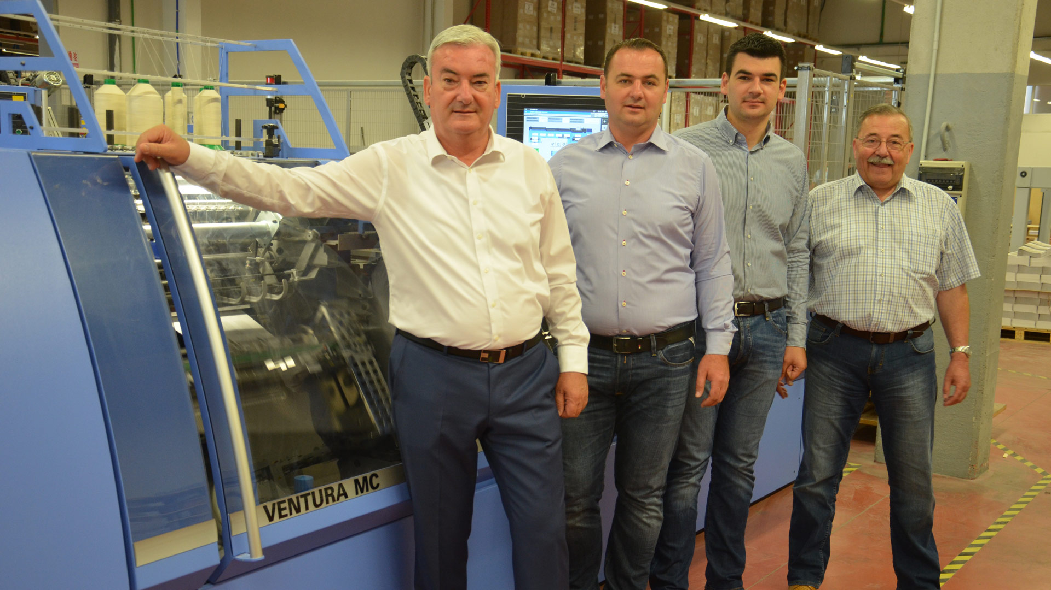

Company founder Stipan Vranješ (left) together with his two sons Nikola (General Director and Director of Production/second from left) and Marko (Deputy General Director) as well as Željko Pokupec (Director of the Croatian Muller Martini agency Pokugraf) in front of a Ventura MC 200 at Grafotisak.

The successful family business, which has been in existence since 1983, produces over 25 million books a year in Grude with around 350 employees, 92 percent of which are exported. 80 percent of all sheets printed by Grafotisak are thread-sewn. It is true that print runs have fallen from 5000 to 4000 copies per title in recent years. But the number of jobs with formats between B5 and A4 is increasing because more and more books are being thread-stitched that used to be perfect bound. Marko Vranješ sees two primary reasons for this: "Firstly, it's a question of quality – and secondly, the price, which has fallen sharply for thread-sewn products."

Based on the excellent experience with the Ventura and the long-standing partnership with Muller Martini, it was clear to Marko Vranješ "that we would choose the same type of book sewing machine again." The two new Ventura MC 200s will again be linked together next May to form a Connect system with 24 stations. Grafotisak has a total of four VenturaConnect systems. The use of VenturaConnect systems pays off, especially when it comes to counteracting price pressure in thread sewing.

In addition, the innovative company, which in addition to books also produces folders, fine cardboard boxes and, as a specialty of the company, security products, and has four office supplies stores with around 15,000 articles in Grude, Sarajevo, Tuzla and Banja Luka, relies on numerous other Muller Martini systems for finishing. These include two Alegro and Bolero perfect binding lines, two Diamant MC hardcover booklines with a Collibri gluing machine and a Primera E140 saddle stitcher.

The Grafotisak Group, which employs a total of 650 people, also includes Fokus Ltd. for school and office supplies in Croatia and Serbia, and the GPS Group in Austria, which specializes in the production of school books. It is true that the pandemic is also affecting Grafotisak's business performance. "But we are fighting, and we are doing pretty well," says Marko Vranješ. "We are well positioned in the market, we have loyal customers, and we are confident that the book will retain its value beyond the corona crisis."

