Medien-Information

Datum 25.02.2021
Nr. PI 2283
Anzahl Zeichen 1241
Kontakt Müller Martini AG
Untere Brühlstrasse 17, 4800 Zofingen/Schweiz
Telefon +41 62 745 45 45
info@mullermartini.com, www.mullermartini.com

Two New Muller Martini Systems for Hua Yun Printing in Hefei

Following the Open House in Nanjing, Hua Yun Printing in Hefei signed a contract for the purchase of two new finishing systems from Muller Martini – an Alegro perfect binder and a Primera MC saddle stitcher.

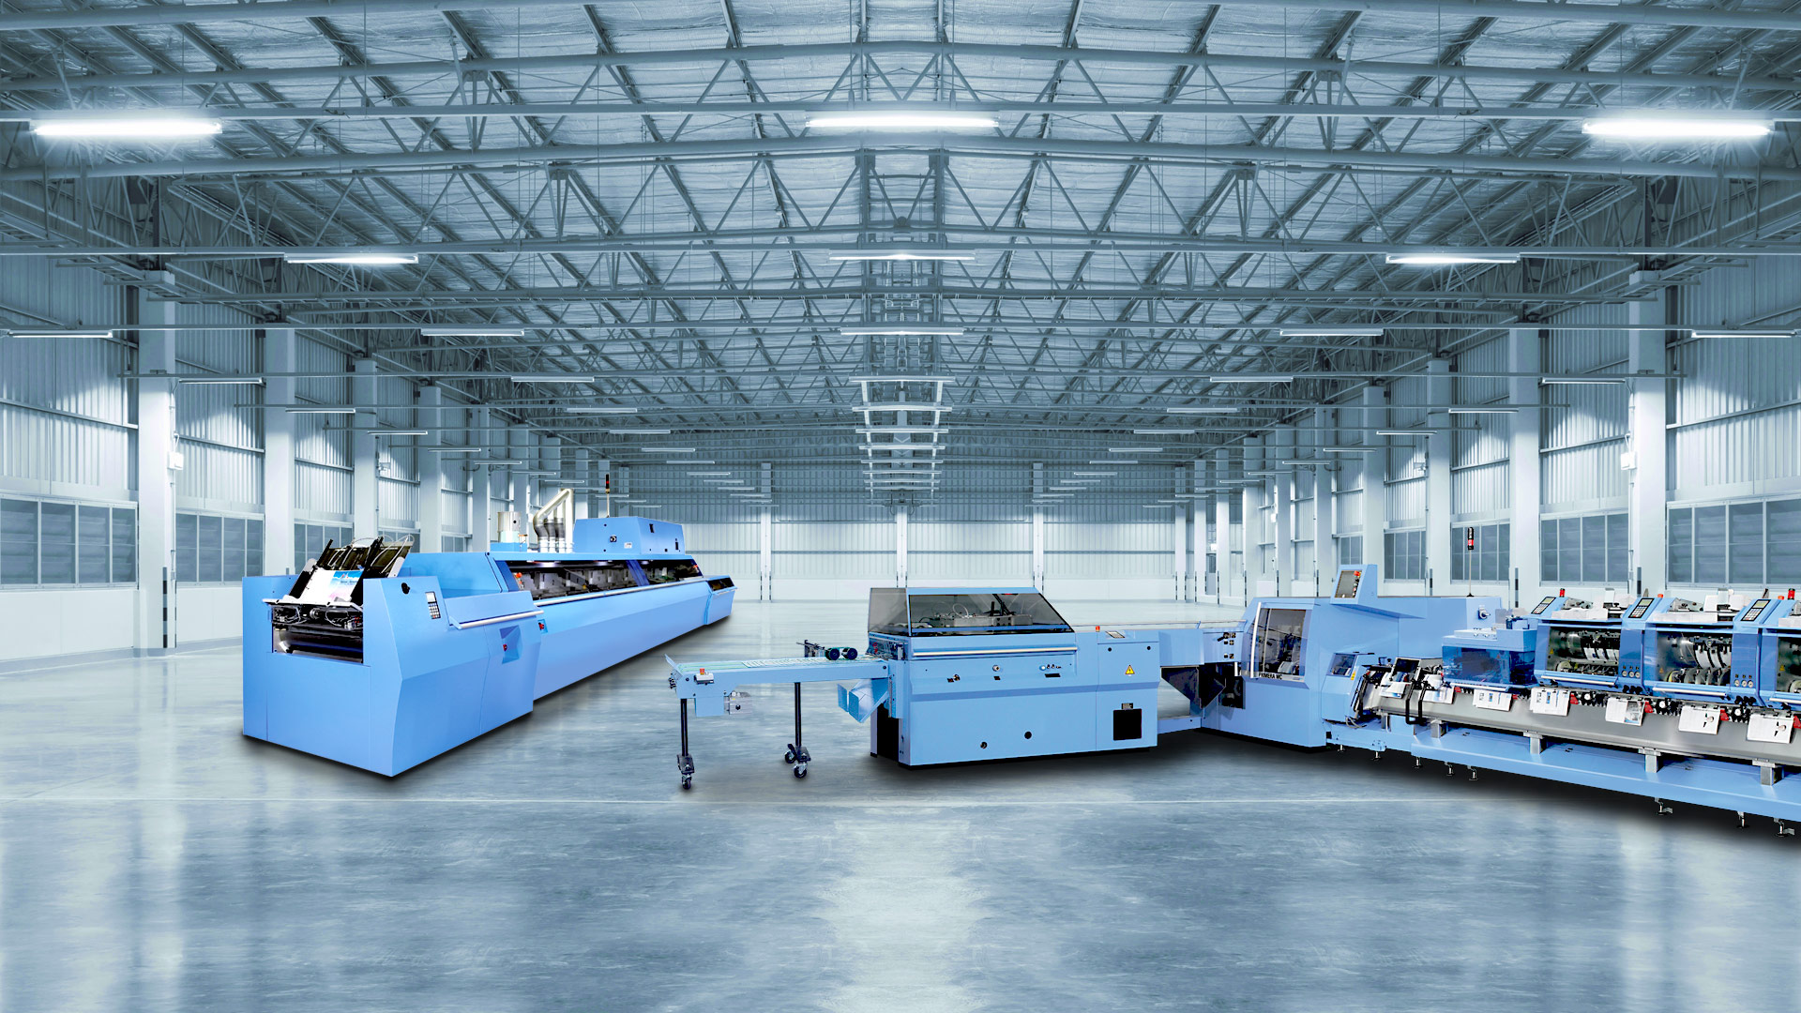
"Thanks to this investment, we will significantly increase our productivity and the quality of our products," says Wu Dahua, Managing Director at Hua Yun Printing, explaining the choice for Muller Martini. "We chose the Alegro for its fast make-ready, and the Primera MC for its high output and more efficient production that minimizes manual intervention."

Hua Yun Printing will be commissioning an Alegro perfect binder and a Primera MC saddle stitcher from Muller Martini in the coming months.

Founded in 1998 and employing around 220 people, Hua Yun Printing is based in Hefei City in the Chinese province of Anhui. The company is mainly active in publishing and commercial printing. It has been a Muller Martini partner for many years, as Hua Yun Printing also has a 1509 saddle stitcher, a Pantera perfect binder and a Ventura MC 200 book sewing machine in operation. The installation of the two new machines is planned for the second quarter of 2021.

