Medien-Information

Datum 09.12.2020
Nr. PI 2272
Anzahl Zeichen 569
Kontakt Müller Martini AG
Untere Brühlstrasse 17, 4800 Zofingen/Schweiz
Telefon +41 62 745 45 45
info@mullermartini.com, www.mullermartini.com

The SigmaLine III Is Now Multifunctional

Pre-gathering, variable folding, dynamic mode for trimming – the SigmaLine III digital book block solution from Muller Martini, which is predestined for ultra-short runs, enables new and varied forms of production.

Previously, the SigmaLine used a mechanical blade for folding. It now uses the innovative air blade technology. With this technology, the folding process is initiated via air pressure. The air blade makes it possible to produce high speeds in a much more stable manner. The fold is improved and there are fewer stoppages. This results in a much higher performance of the entire system, up to 1,000 feet or 305 meters per minute – the highest output of digitally produced book blocks on the market.

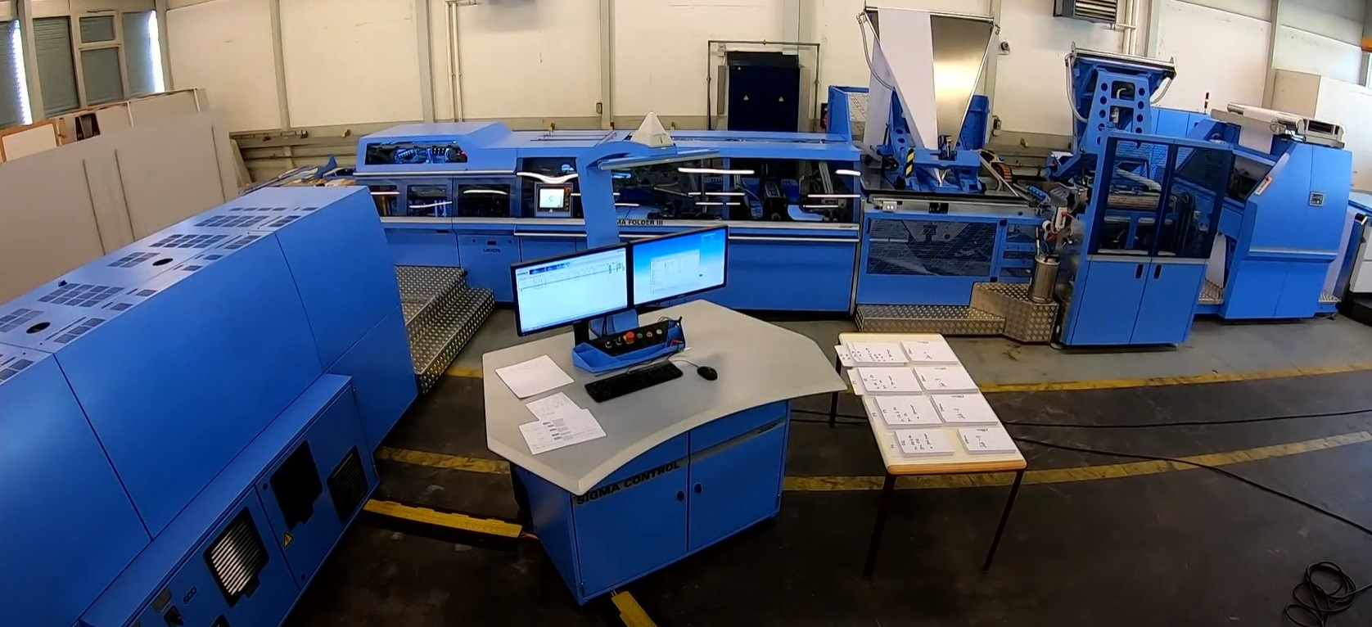
The SigmaLine III can now be used to make two consecutive trims. This makes it possible to avoid a cross fold if necessary.

Thanks to its variability, the air blade technology also offers extended production possibilities. Several signatures can be pre-collected in the longitudinal folder before being folded together. This allows several separate signatures to be combined into a single signature. For example, three 8-page signatures can be turned into one 24-page signature – an ideal pre-product for thread or saddle stitching. This multifunctional application thus gives our customers a much higher level of investment protection.

Dynamic Trimming Mode
Another great new feature is the dynamic trimming mode. Previously, the cutting/perforating/cutting process always resulted in a cross fold. Now the SigmaLine III can cut twice in succession. This means that the cross fold can be bypassed. Thanks to the dynamic mode, the page divisibility of the book blocks can now be halved so that there are fewer blank pages. Previously, it was possible for a 16-sheet to have up to 15 empty pages. Now there are 8-sheet books with a maximum of 7 empty pages.

The SigmaLine III, which is typically used for very short runs of books (both publishing and self-publishing), has a very high level of integration with digital web presses, just like its predecessor models. If a product is printed incorrectly, it is immediately rejected and reordered from the press.

Practically no manual intervention necessary
The level of automation of the book block solution, which is unique on the market, also remains high. It is modular and based on a building block principle and can be adapted to new market requirements at any time. With Finishing 4.0 in its purest form, practically no manual intervention is required.

Like its predecessor models, the SigmaLine III has a very high level of integration with digital web presses. In the rapidly developing environment with shorter life cycles of digital presses, the book block solution comprehensively demonstrates its open concept with the Generic Digital Press Interface.

Box

The Highlights of the SigmaLine III

➢ The SigmaLine III connects digital printing and print finishing to a unique complete system – PDF in, book out.

➢ With the SigmaLine III, individual signatures and pre-glued book blocks in runs as small as one copy can be prepared for book production, and pre-gathered signatures can be prepared for thread sewing and saddle stitching.

➢ Thanks to the high degree of automation, setup times between size and job changes when operating at full speed are short and the number of employees required to run the line is minimal.

➢ With the SigmaLine III, paper widths of 18 to 60 inches can be processed, depending on the configuration.

