Press Release

Date 02.11.2020
No. PI 2265
Number of characters 455
Contact Muller Martini AG
Untere Brühlstrasse 17, 4800 Zofingen, Switzerland
Phone +41(0)62 745 45 45
info@mullermartini.com, www.mullermartini.com

New Primera PRO saddle stitcher:
the three-knife trimmer is fully automated

Just one month after launching the Prinova, which has a capacity of 9,000 cycles per hour, Muller Martini is doubling its output and this November is launching a second new saddle stitcher, the Primera PRO. One of the highlights of the 14,000 cycle machine is its completely redesigned, variable-thickness three-knife trimmer.

The three-knife trimmer of the Primera PRO is fully automated. Thanks to advanced Motion Control technology and servo drives, each of its format axes can be individually adjusted in case of any corrections – without compromise and without affecting other axes. In addition, no brushes are needed for product guidance, only belts. These do not need to be adjusted – everything happens automatically.

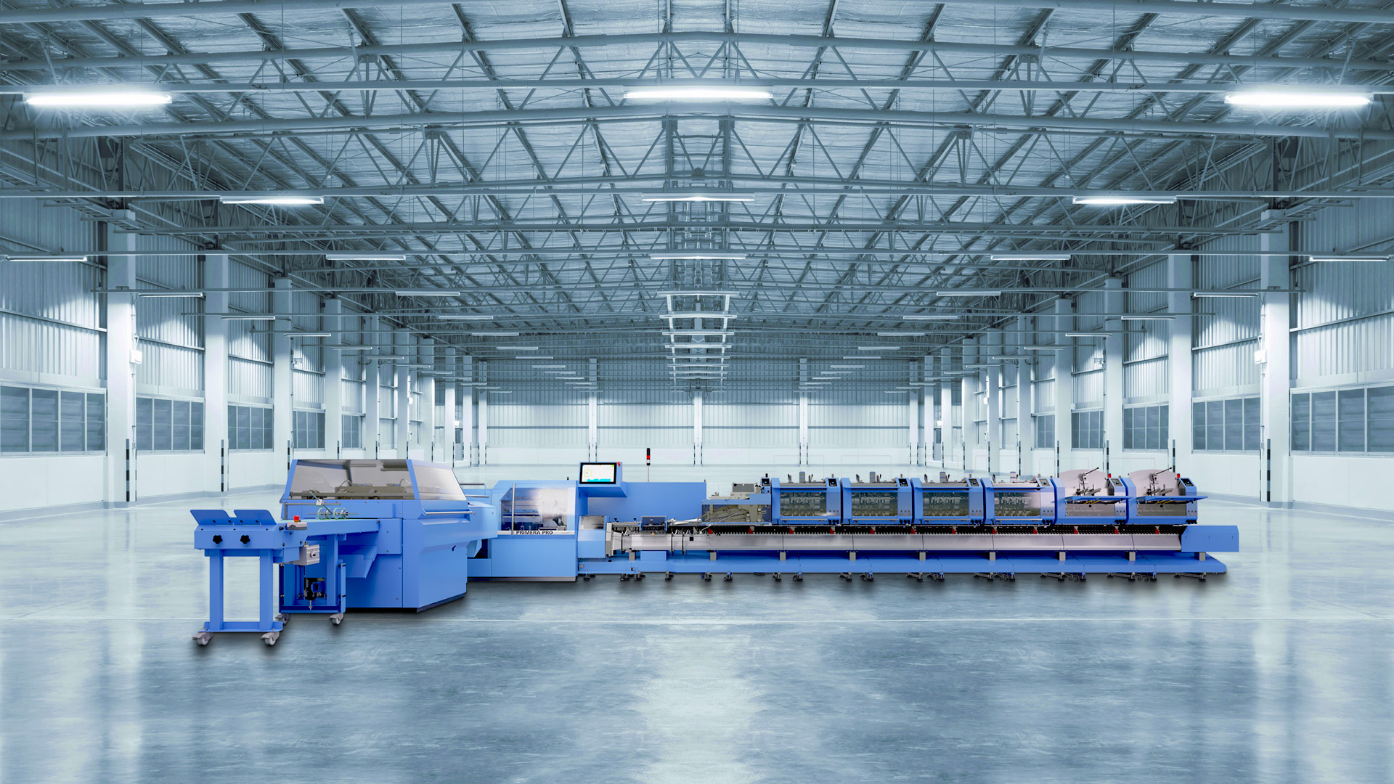
Manual intervention is a thing of the past with the three-knife trimmer of the new Primera PRO saddle stitcher.

With the center cut, the left and right (product) sections can be adjusted independently of each other. Any corrections can then be saved on the central control panel of the Primera PRO for interrupted or repetitive jobs and recalled in the same way at any time. Format and thickness settings – including asymmetries such as thickness, stops and cutting elements – are fully automated, as is product centering. If you're tired of time-consuming manual intervention at the three-knife trimmer of your saddle stitcher, the new Primera PRO is just right for you. The machine operators don't have to adjust anything by hand – not even the newly integrated full-format side centering for perfect head trim accuracy.

Automation lowers costs
But it's not just the three-knife trimmer that makes the new 14,000 cycles per hour Primera PRO stand out. The targeted expansion of the Motion Control technology for the entire machine ensures a significant reduction in job setup and throughput times and increases profitability thanks to the fast and error-free setup processes.

To optimize the production process in the delivery, perfect quality is achieved – the first product can be sold right away. In addition, the independent decoupling of the gathering chain, stitcher and ejector systems opens up new application possibilities such as the flexible stitching head position for format changes. Together with its high format variability, the Primera PRO is therefore the ideal saddle stitcher for a wide range of products – for short runs as well as longer runs.

Fast learning thanks to new interaction
The completely redesigned, even more user-friendly operating concept for the Primera PRO – intuitive operation with local control units and a large touch screen with redesigned visualization – allows context-sensitive displays and standardized user guidance. The new interaction is therefore particularly easy to learn, which in turn reduces the need for training. This reduces costs and is also a great advantage when changing personnel.

