Press Release

Date 28.04.2020
No. PI 2249
Number of characters 2099
Contact Muller Martini AG
Untere Brühlstrasse 17, 4800 Zofingen, Switzerland
Phone +41(0)62 745 45 45
info@mullermartini.com, www.mullermartini.com

Muller Martini Provides Service for Customers in Wuhan

Shortly after the measures to combat the Covid pandemic were eased in Hubei, the hardest hit of China’s provinces, Muller Martini began a free service program to support its customers in the region.

“Muller Martini appreciates the excellent partnership and collaboration it has enjoyed with our customers in China for many years,” says Sven Olsen, Head of the Muller Martini Asia Pacific region, explaining the launch of the special assistance program. “During these difficult times, we want to do something to show our appreciation.” For this reason, Muller Martini is offering Chinese customers who have been most affected by the novel coronavirus a free service package for the month of April.

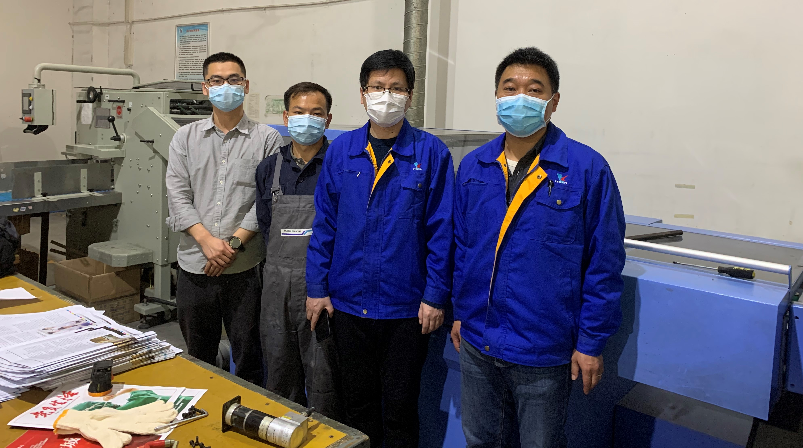
The members of the management team at Hubei Xinhua Printing are very grateful for the service provided by the Muller Martini staff (from left): Ken Dong and Li Zhihua (Muller Martini) with Yunliang Yang (General Manager of Hubei Xinhua Printing) and Jie Li (Head of the Machine Department at Hubei Xinhua Printing).

Immediately after the launch of the program, Muller Martini received responses from several customers in the city of Wuhan who needed help in restarting their machines following a two-month shutdown. A three-member service team from Shanghai was able to provide them with quick and seamless assistance.

Barely a week after the last restrictions were lifted, experienced staff from the sales and service management department Li Zhihua, Tony Liao and Ken Dong set out from Shanghai by car and reached customers in Wuhan following a two-day drive. When they arrived, they carried out inspections, adjusted production settings, conducted maintenance and provided training for the machine operators.

Yunliang Yang, General Manager of Hubei Xinhua Printing, was very grateful for the support that was provided: “Many thanks to Muller Martini for the extraordinary assistance it has provided during these difficult times. This commitment moved us deeply. Muller Martini is currently the only machine manufacturer to offer this sort of support.

