Press Release

Date 5/23/2019
No. PI 2200
Number of characters 2621
Contact Muller Martini AG
Untere Brühlstrasse 13, CH-4800 Zofingen/Switzerland
Tel. +41 (0)62 745 45 75, Fax +41 (0)62 751 55 50
info@mullermartini.com, www.mullermartini.com

New Primera MC for the Möller Media Group:
three become two

From July, the new Primera MC saddle stitcher from Muller Martini will replace two of the three existing saddle stitchers at the Möller Media Group in Ahrensfelde near Berlin, Germany.

The Möller Media Group, which employs 150 staff, currently produces catalogs and magazines on their saddle stitchers in print runs of between 5,000 and 200,000 copies. In order to ensure they can continue to offer the complete portfolio of a full-service operation with pre-press, printing and print finishing services in future, the long-serving Prima S and PrimaPlus saddle stitchers are now being replaced by a new Primera MC from Muller Martini. The Primera C140 saddle stitcher, which has been in use since 2013, will remain in operation. “With an annual sales volume of 22 million euros in the printing division, high-performance saddle stitching is essential at our company,” comments Sylvio Antmann, Managing Director at the Möller Media Group. “What’s more, the Primera MC is taking over the work of two old saddle stitchers – an ideal solution for us.”

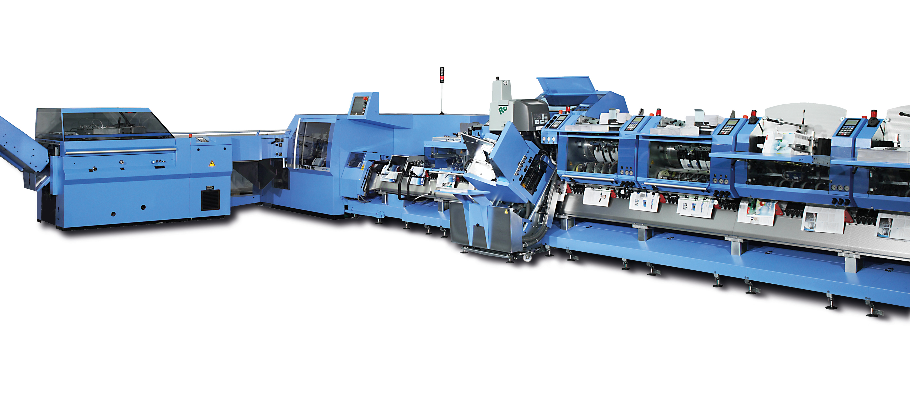
Three become two: The new Primera MC saddle stitcher from Muller Martini replaces two of the three existing saddle stitchers at the Möller Media Group.

In order to meet the required volumes while also increasing productivity and improving the stitching quality, the traditional family-run company is now replacing the Prima S and PrimaPlus saddle stitchers from Muller Martini – which have been in use for 17 and 13 years, respectively – with a saddle stitcher of the latest generation. “The required cost-benefit ratio could no longer be ensured with the old machines,” says Sylvio Antmann, explaining the latest investment decision. “And we have long had good experiences with Muller Martini machines.”

Customers of the Möller Media Group consist of international and national shipping, commercial and industrial companies, and can also be found in the publishing and media industry. 40 percent of the orders received are perfect-bound and 60 percent spine-stitched – another reason for investing in a powerful and reliable new saddle stitcher.

The new Primera MC, which is equipped with eight stations, a merchandise tipper and a Perfetto compensating stacker, continues the long tradition of using machines from Muller Martini and Kolbus at the Möller Media Group. The existing Primera C140 saddle stitcher and the Publica S perfect binder from the Kolbus brand have also been successfully in operation here for years. As Sylvio Antmann emphasizes: “Muller Martini is the best choice when it comes to longevity.”

